AWS Serverless ETL Pipeline
Complete Project Documentation
S3 → Lambda → Glue Visual ETL → EventBridge → SNS → CloudWatch
Bucket: server-aws-etl | Lambda: activate-s3 | Glue Job: s3-glue-active
Region: us-east-1 | Date: June 18, 2026

Project Architecture (Quick Overview)
This document walks through every distinct step of building a fully serverless ETL pipeline on AWS. Raw CSV data is uploaded to S3, a Lambda function reacts to the event, an AWS Glue Visual job removes duplicates, and EventBridge + SNS send email notifications. All activity is visible in CloudWatch.
Phase 1 – Amazon S3 Setup
Create bucket server-aws-etl and folder structure (load / extract).
Phase 2 – AWS Lambda
Create function activate-s3, attach IAM role, write handler, add S3 trigger.
Phase 3 – IAM Hardening
Review and confirm least-privilege permissions on the Lambda role.
Phase 4 – CloudWatch Logs
Verify automatic log group creation and inspect execution logs.
Phase 5 – AWS Glue Visual ETL
Build visual job s3-glue-active with Drop Duplicates transform and run it.
Phase 6 – EventBridge + SNS
Route S3 and Glue events to SNS topic for email notifications.
Phase 7 – End-to-End Verification
Upload data, confirm Glue success, and receive Gmail notifications.

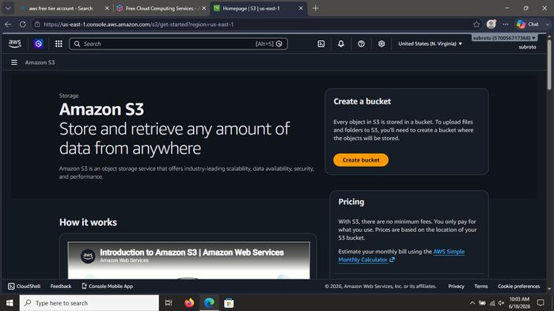
What was done: Opened the Amazon S3 console (us-east-1). Landing page shows the S3 service overview and the option to create a new bucket.

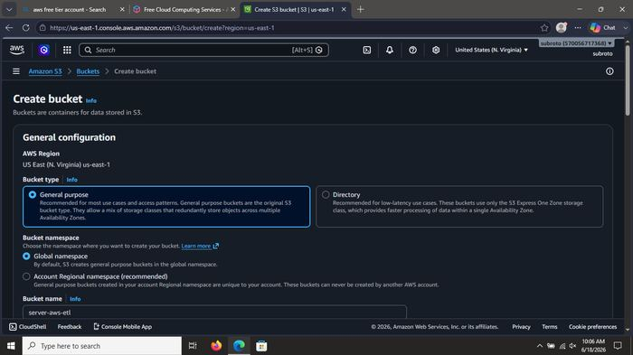
What was done: Started the Create bucket wizard. Selected General purpose bucket type and began configuring the new bucket named server-aws-etl.

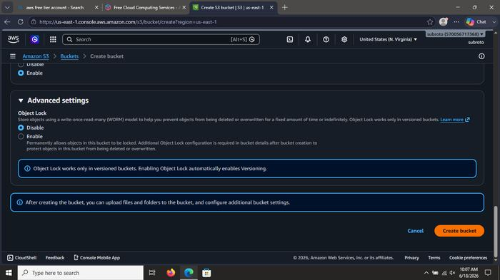
What was done: Configured general settings for the bucket: AWS Region us-east-1, Global namespace, and entered the bucket name server-aws-etl.

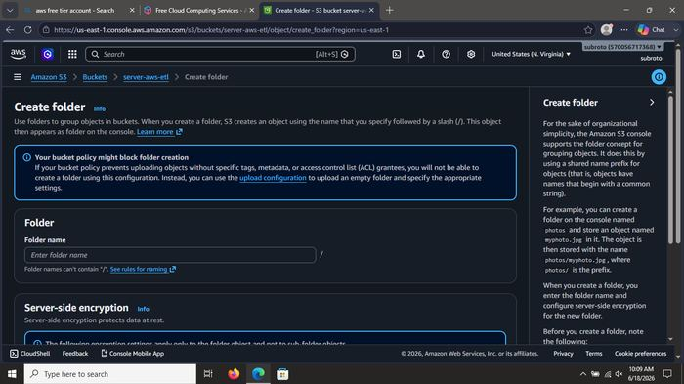
What was done: Reviewed advanced settings (Object Ownership, Block Public Access, Versioning, Encryption). Kept secure defaults (Block all public access enabled).

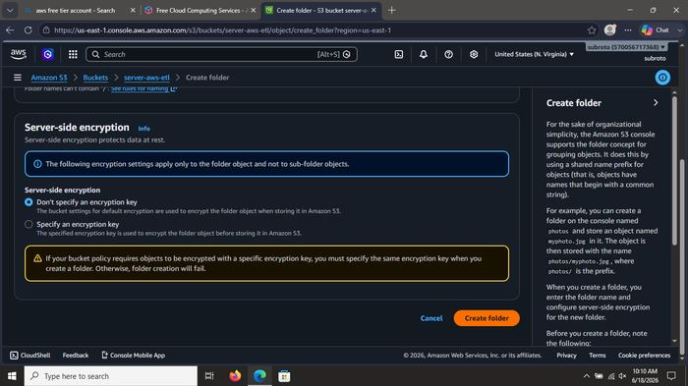
What was done: Reviewed advanced settings (Object Ownership, Block Public Access, Versioning, Encryption). Kept secure defaults (Block all public access enabled).

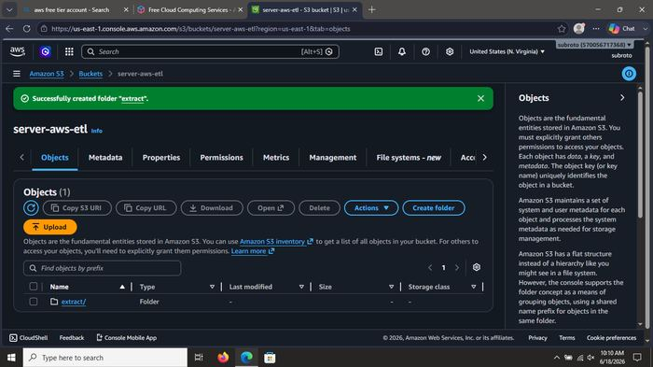
What was done: Reviewed advanced settings (Object Ownership, Block Public Access, Versioning, Encryption). Kept secure defaults (Block all public access enabled).

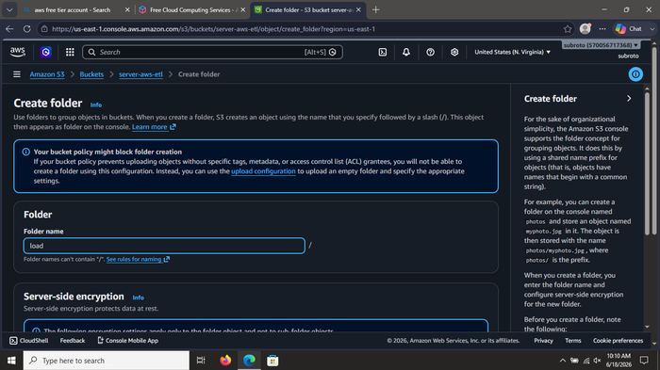
What was done: Created the first folder inside the bucket. Folder name entered: load (used later for processed/output data).

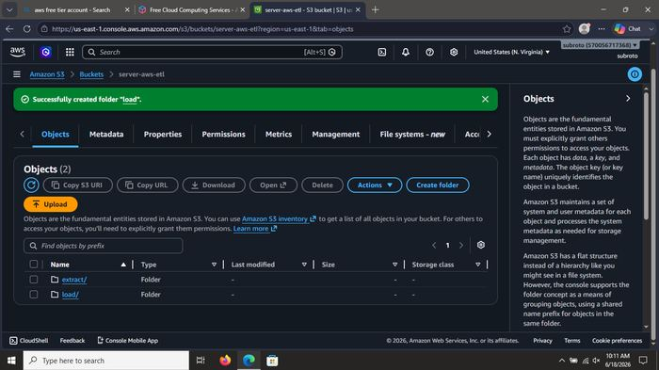
What was done: Bucket server-aws-etl successfully created. Verified bucket appears in the S3 console and folder structure is ready.

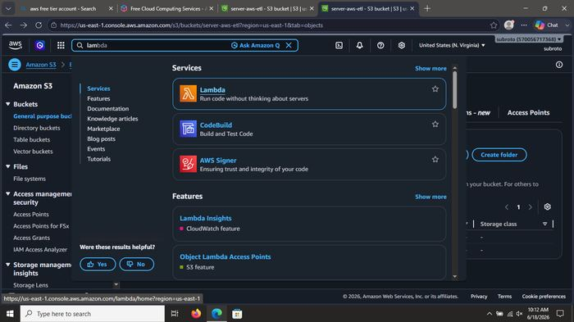
What was done: Bucket server-aws-etl successfully created. Verified bucket appears in the S3 console and folder structure is ready.

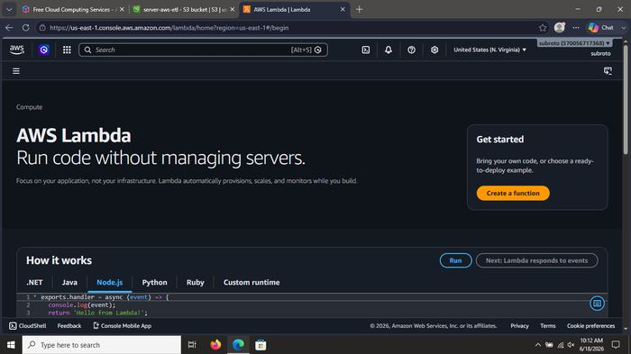
What was done: Bucket server-aws-etl successfully created. Verified bucket appears in the S3 console and folder structure is ready.

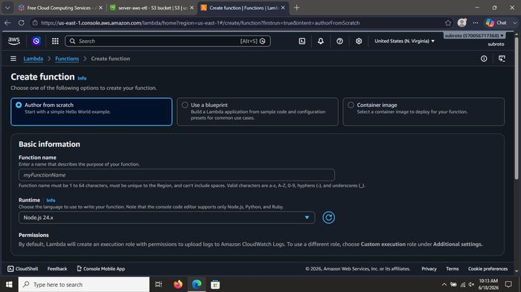
What was done: Continued organizing the S3 data lake structure (folders such as load / extract) and navigated the bucket contents before moving to Lambda.

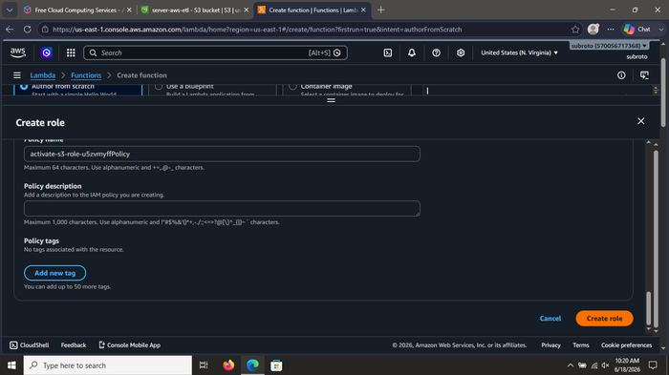
What was done: Continued organizing the S3 data lake structure (folders such as load / extract) and navigated the bucket contents before moving to Lambda.

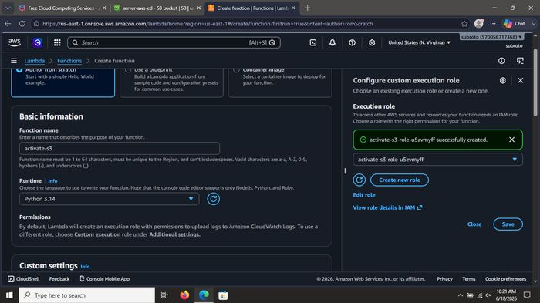
What was done: Opened AWS Lambda → Create function. Chose Author from scratch. Prepared to name the function activate-s3 and select Python runtime.

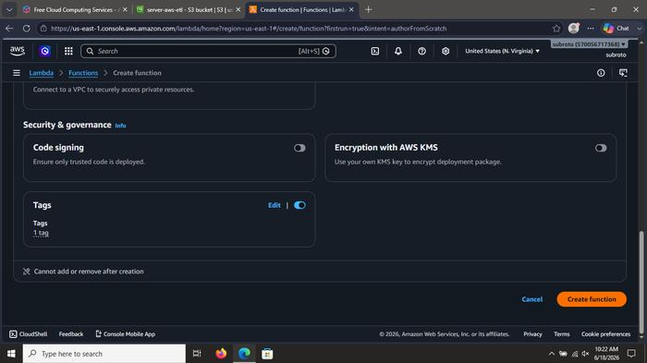
What was done: Opened AWS Lambda → Create function. Chose Author from scratch. Prepared to name the function activate-s3 and select Python runtime.

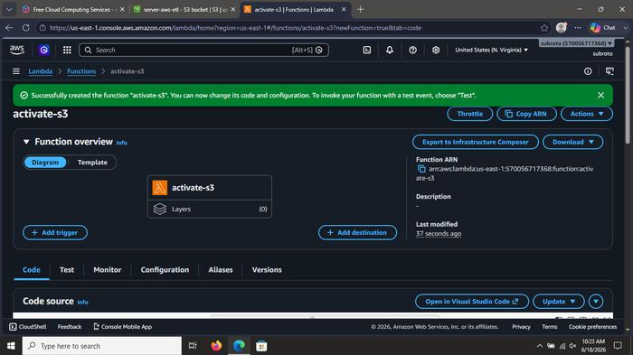
What was done: Configured the Lambda execution role. Created custom IAM role activate-s3-role-u5zvmyff so the function can write logs and interact with S3.

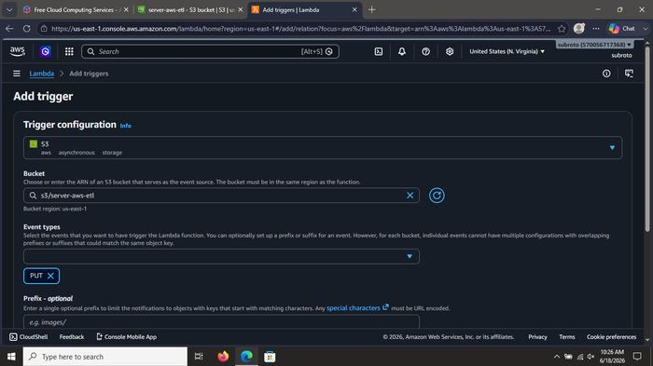
What was done: Configured the Lambda execution role. Created custom IAM role activate-s3-role-u5zvmyff so the function can write logs and interact with S3.

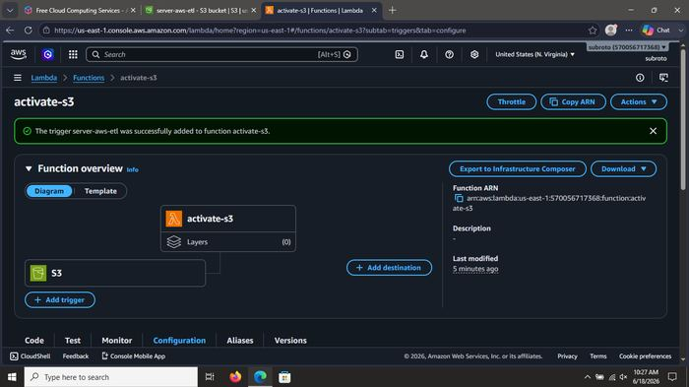
What was done: Configured the Lambda execution role. Created custom IAM role activate-s3-role-u5zvmyff so the function can write logs and interact with S3.

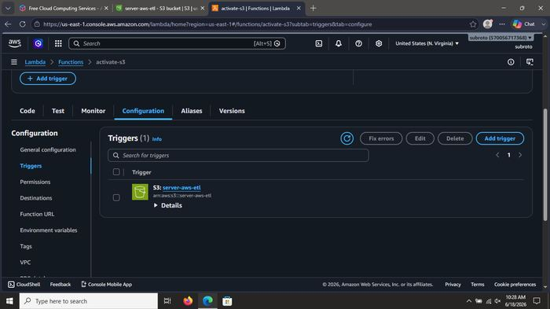
What was done: Configured the Lambda execution role. Created custom IAM role activate-s3-role-u5zvmyff so the function can write logs and interact with S3.

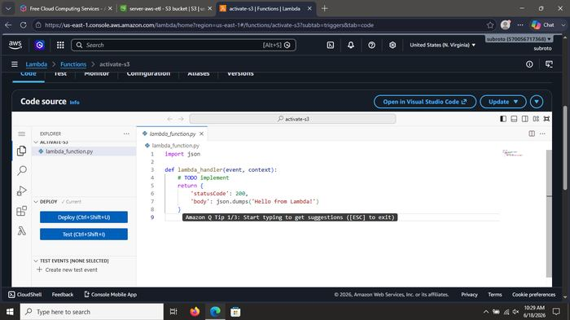
What was done: Configured the Lambda execution role. Created custom IAM role activate-s3-role-u5zvmyff so the function can write logs and interact with S3.

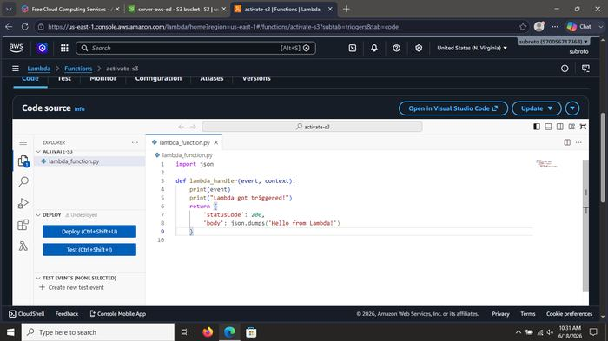
What was done: Wrote the Lambda handler code (Python). Simple function that prints the incoming S3 event and returns HTTP 200 with a success message.

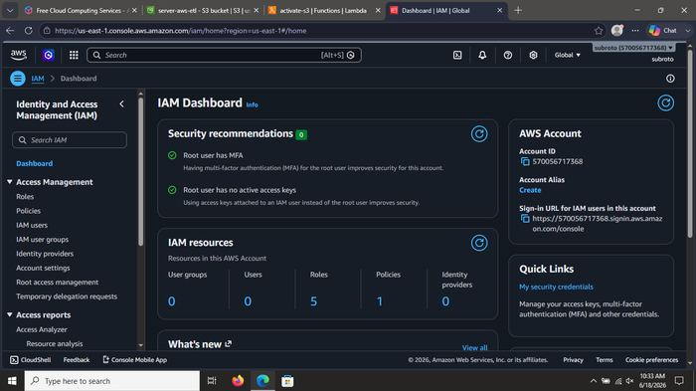
What was done: Wrote the Lambda handler code (Python). Simple function that prints the incoming S3 event and returns HTTP 200 with a success message.

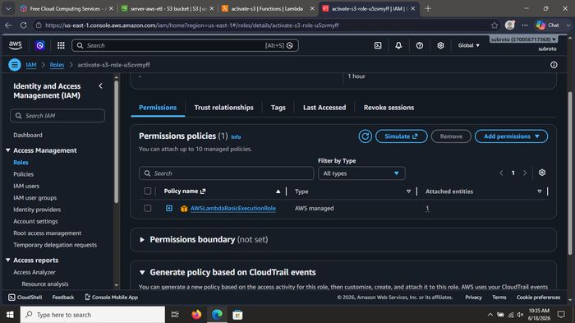
What was done: Wrote the Lambda handler code (Python). Simple function that prints the incoming S3 event and returns HTTP 200 with a success message.

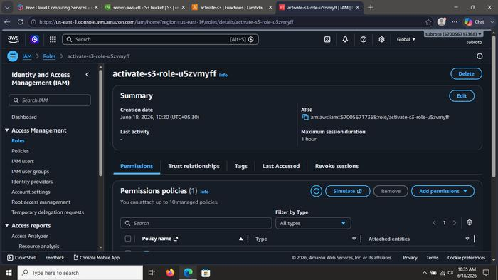
What was done: Wrote the Lambda handler code (Python). Simple function that prints the incoming S3 event and returns HTTP 200 with a success message.

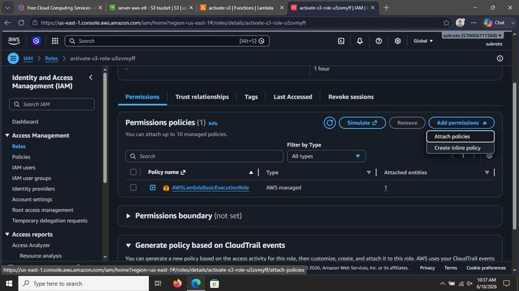
What was done: Deployed the Lambda function and ran a test event named s3-put. Execution succeeded – confirmed the function is ready to receive real S3 events.

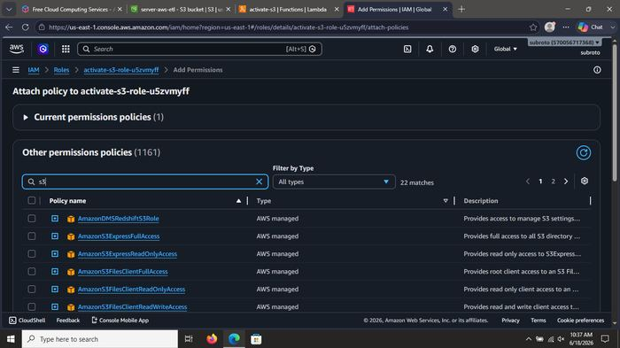
What was done: Deployed the Lambda function and ran a test event named s3-put. Execution succeeded – confirmed the function is ready to receive real S3 events.

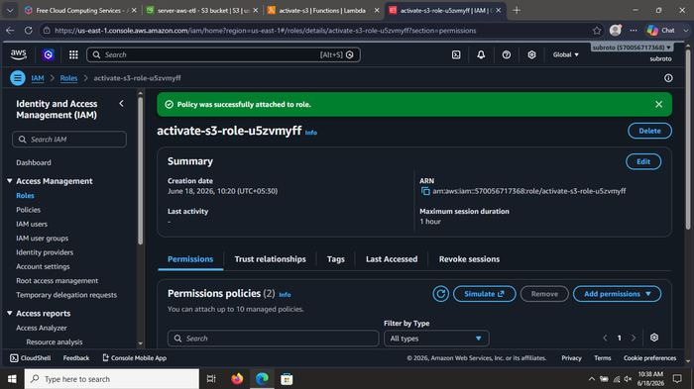
What was done: Deployed the Lambda function and ran a test event named s3-put. Execution succeeded – confirmed the function is ready to receive real S3 events.

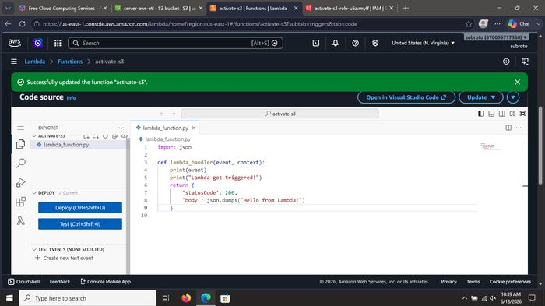
What was done: Deployed the Lambda function and ran a test event named s3-put. Execution succeeded – confirmed the function is ready to receive real S3 events.

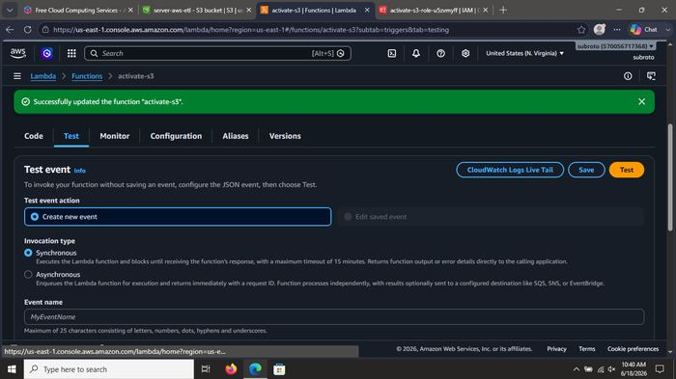
What was done: Attached an S3 trigger to the Lambda function (Object Created events on bucket server-aws-etl). Lambda is now event-driven.

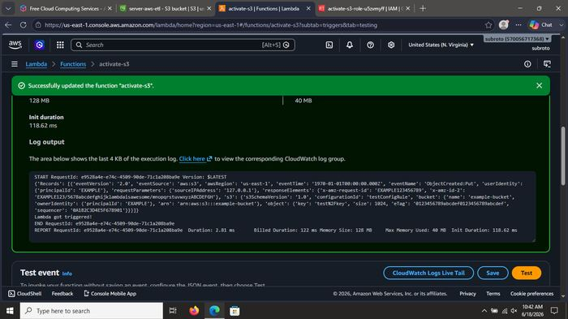
What was done: Attached an S3 trigger to the Lambda function (Object Created events on bucket server-aws-etl). Lambda is now event-driven.

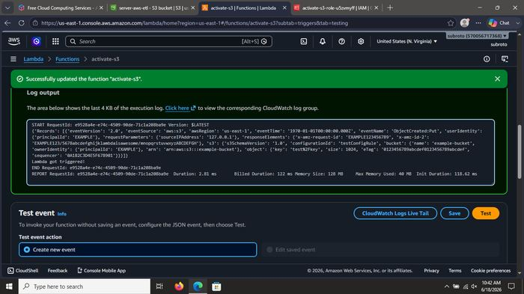
What was done: Attached an S3 trigger to the Lambda function (Object Created events on bucket server-aws-etl). Lambda is now event-driven.

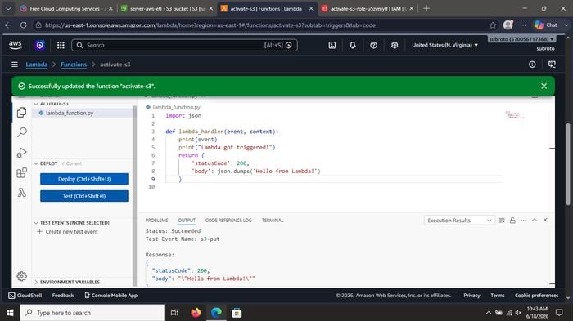
What was done: Attached an S3 trigger to the Lambda function (Object Created events on bucket server-aws-etl). Lambda is now event-driven.

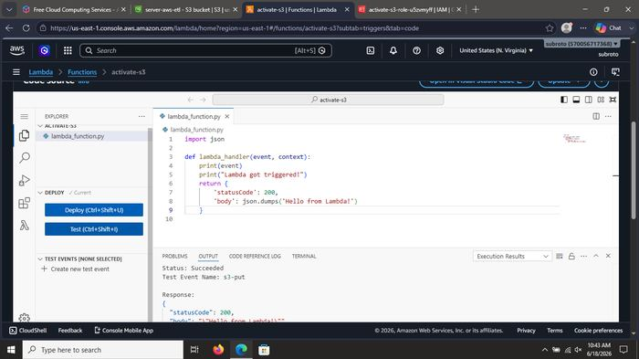
What was done: Reviewed and hardened the IAM role permissions for activate-s3. Confirmed policies allow CloudWatch Logs and necessary S3 access (least privilege).

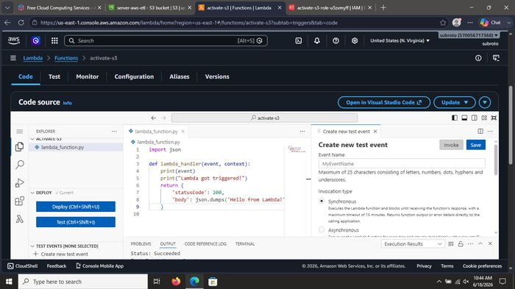
What was done: Reviewed and hardened the IAM role permissions for activate-s3. Confirmed policies allow CloudWatch Logs and necessary S3 access (least privilege).

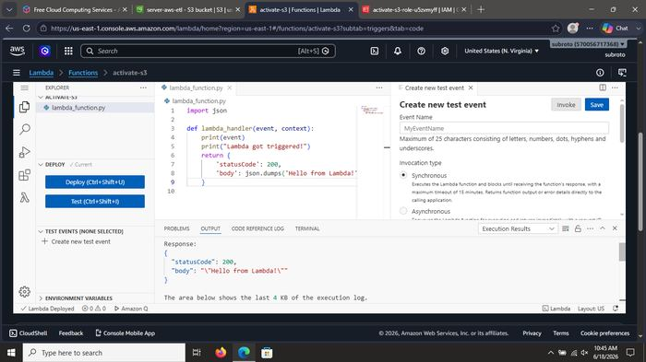
What was done: Reviewed and hardened the IAM role permissions for activate-s3. Confirmed policies allow CloudWatch Logs and necessary S3 access (least privilege).

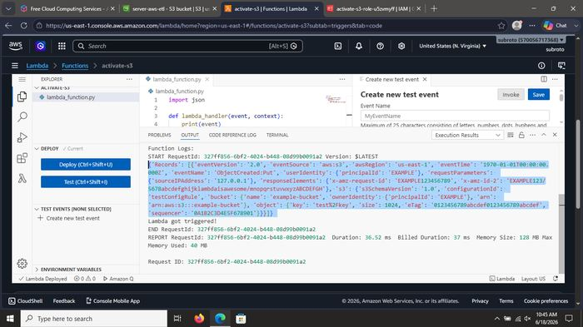
What was done: Reviewed and hardened the IAM role permissions for activate-s3. Confirmed policies allow CloudWatch Logs and necessary S3 access (least privilege).

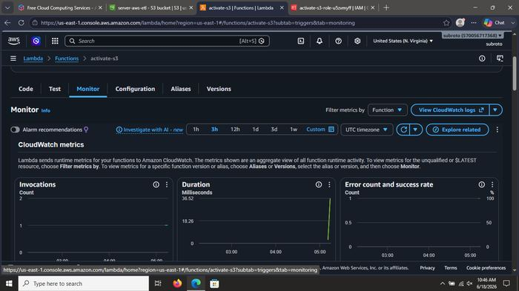
What was done: Reviewed and hardened the IAM role permissions for activate-s3. Confirmed policies allow CloudWatch Logs and necessary S3 access (least privilege).

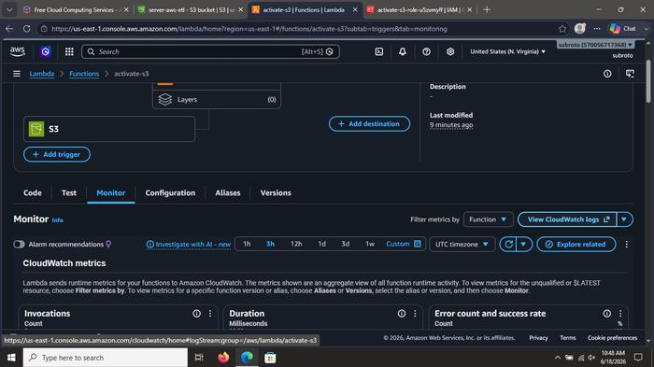
What was done: Reviewed and hardened the IAM role permissions for activate-s3. Confirmed policies allow CloudWatch Logs and necessary S3 access (least privilege).

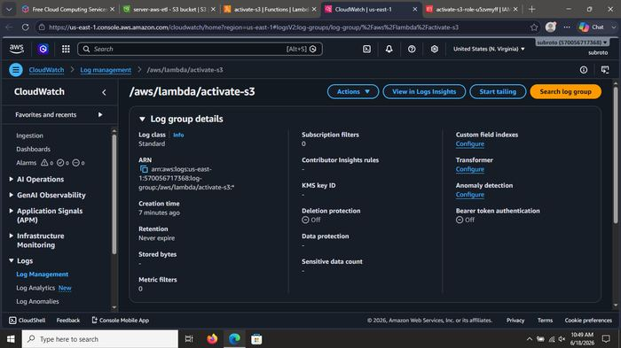
What was done: Reviewed and hardened the IAM role permissions for activate-s3. Confirmed policies allow CloudWatch Logs and necessary S3 access (least privilege).

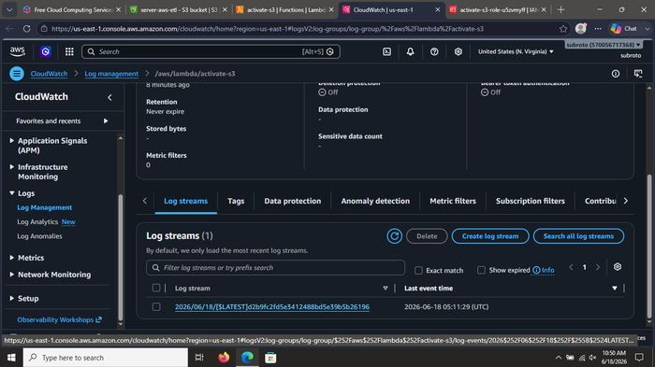
What was done: Reviewed and hardened the IAM role permissions for activate-s3. Confirmed policies allow CloudWatch Logs and necessary S3 access (least privilege).

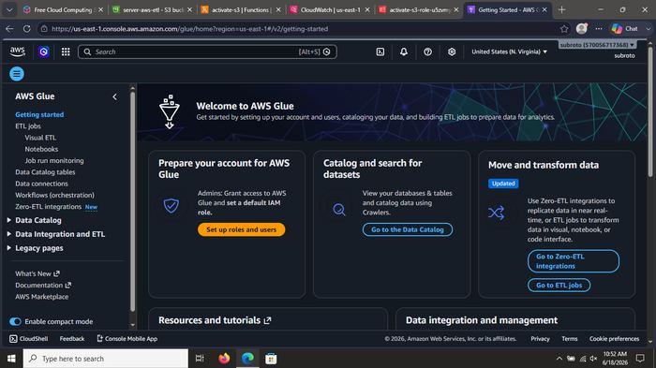
What was done: Reviewed and hardened the IAM role permissions for activate-s3. Confirmed policies allow CloudWatch Logs and necessary S3 access (least privilege).

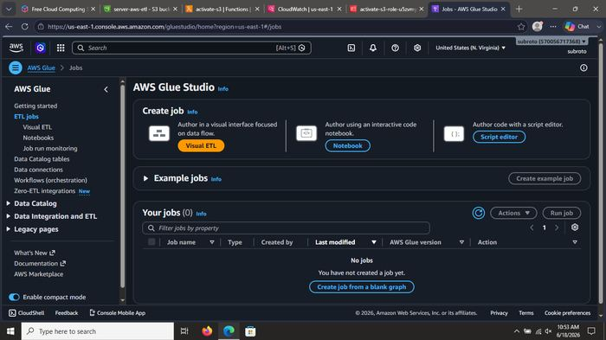
What was done: Reviewed and hardened the IAM role permissions for activate-s3. Confirmed policies allow CloudWatch Logs and necessary S3 access (least privilege).

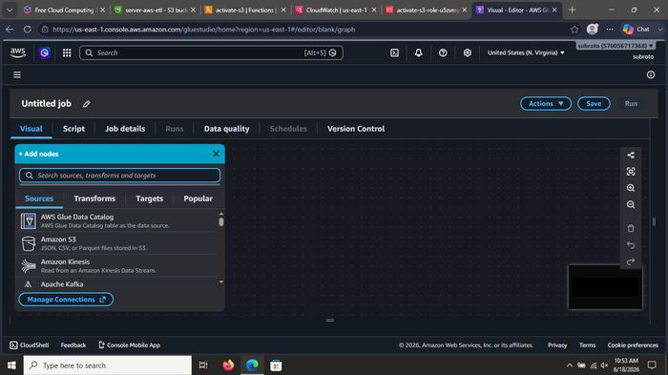
What was done: Opened CloudWatch Logs. Log group /aws/lambda/activate-s3 was automatically created. Inspected log streams to verify Lambda executions.

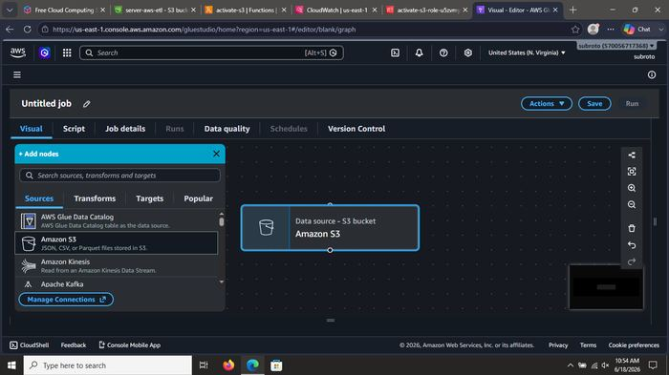
What was done: Opened CloudWatch Logs. Log group /aws/lambda/activate-s3 was automatically created. Inspected log streams to verify Lambda executions.

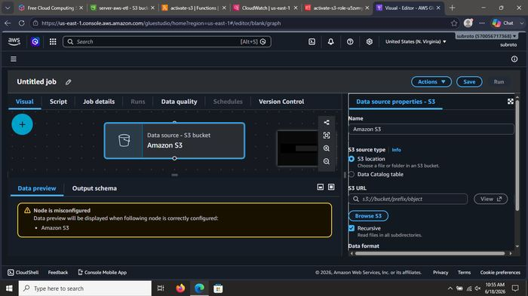
What was done: Opened CloudWatch Logs. Log group /aws/lambda/activate-s3 was automatically created. Inspected log streams to verify Lambda executions.

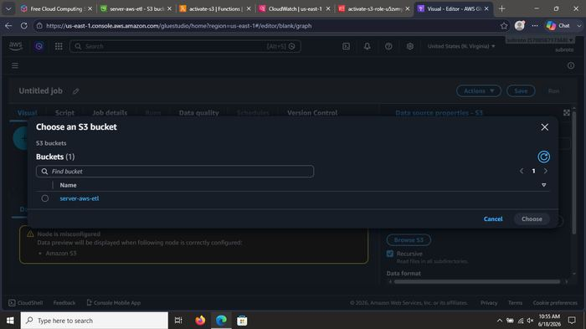
What was done: Opened CloudWatch Logs. Log group /aws/lambda/activate-s3 was automatically created. Inspected log streams to verify Lambda executions.

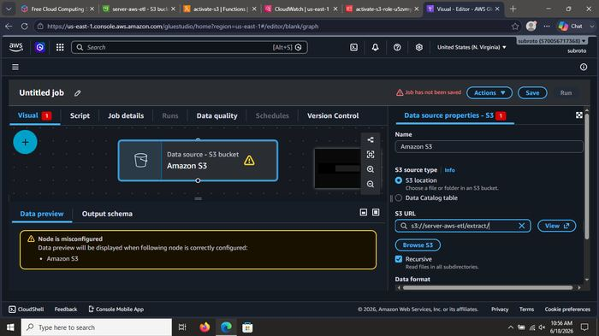
What was done: Opened CloudWatch Logs. Log group /aws/lambda/activate-s3 was automatically created. Inspected log streams to verify Lambda executions.

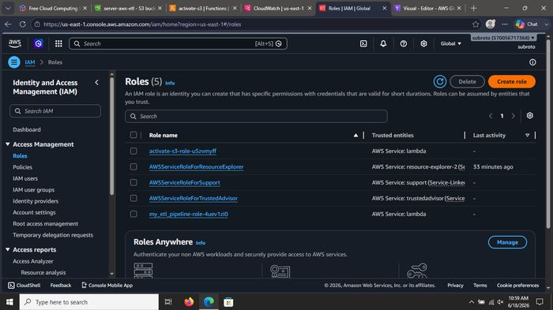
What was done: Opened CloudWatch Logs. Log group /aws/lambda/activate-s3 was automatically created. Inspected log streams to verify Lambda executions.

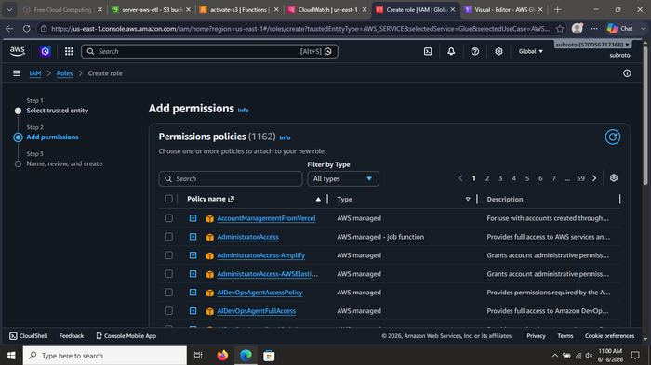
What was done: Opened CloudWatch Logs. Log group /aws/lambda/activate-s3 was automatically created. Inspected log streams to verify Lambda executions.

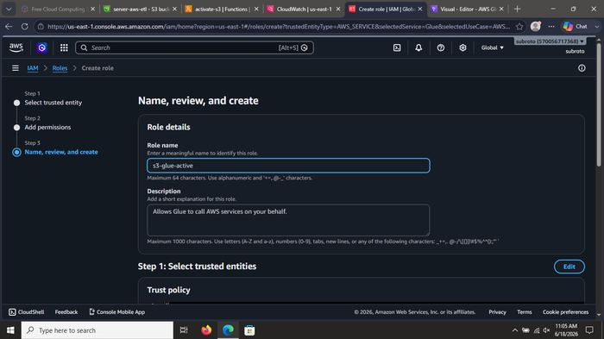
What was done: Opened AWS Glue Studio. Started creating a new Visual ETL job that will clean the data (Drop Duplicates transform).

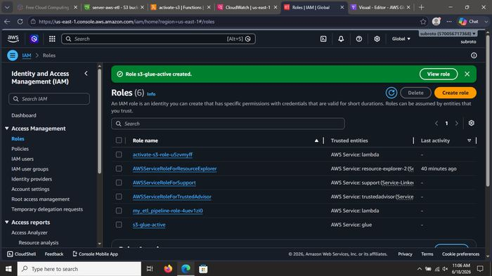
What was done: Opened AWS Glue Studio. Started creating a new Visual ETL job that will clean the data (Drop Duplicates transform).

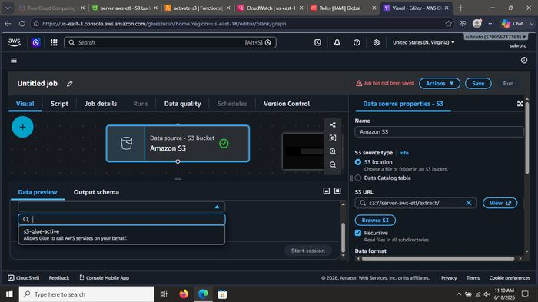
What was done: Opened AWS Glue Studio. Started creating a new Visual ETL job that will clean the data (Drop Duplicates transform).

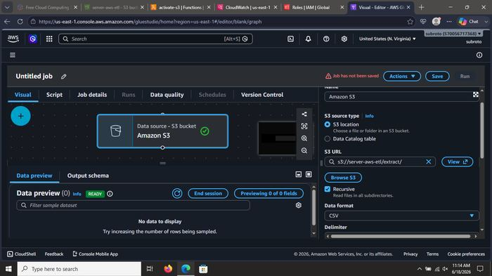
What was done: Opened AWS Glue Studio. Started creating a new Visual ETL job that will clean the data (Drop Duplicates transform).

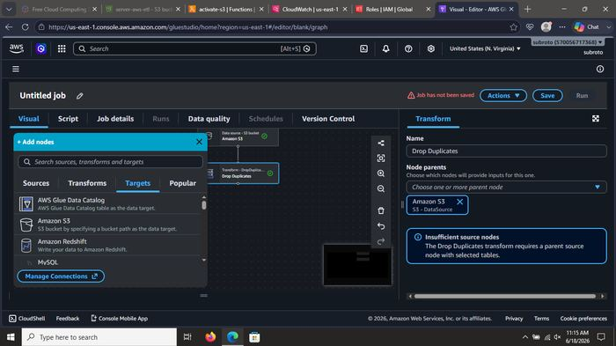
What was done: Opened AWS Glue Studio. Started creating a new Visual ETL job that will clean the data (Drop Duplicates transform).

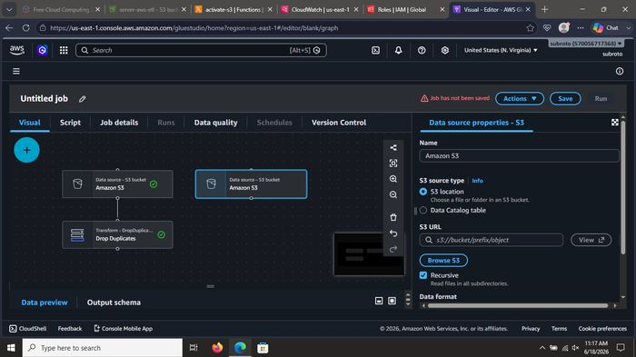
What was done: Configured the Data Source node: selected S3 bucket server-aws-etl as the input location for the ETL job.

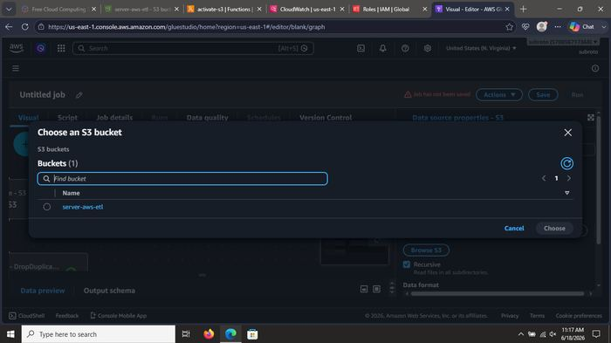
What was done: Configured the Data Source node: selected S3 bucket server-aws-etl as the input location for the ETL job.

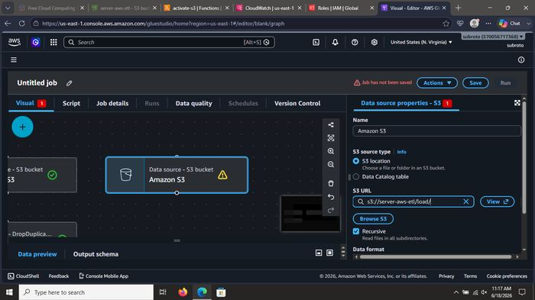
What was done: Configured the Data Source node: selected S3 bucket server-aws-etl as the input location for the ETL job.

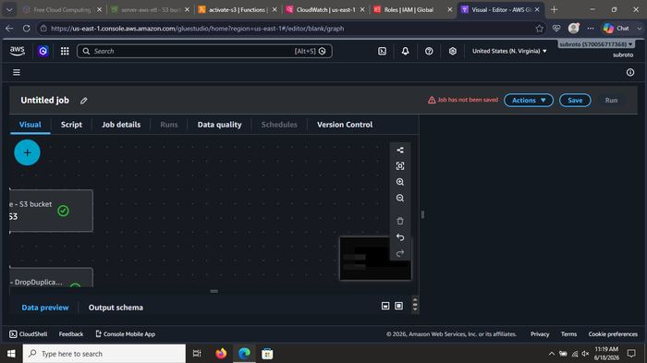
What was done: Configured the Data Source node: selected S3 bucket server-aws-etl as the input location for the ETL job.

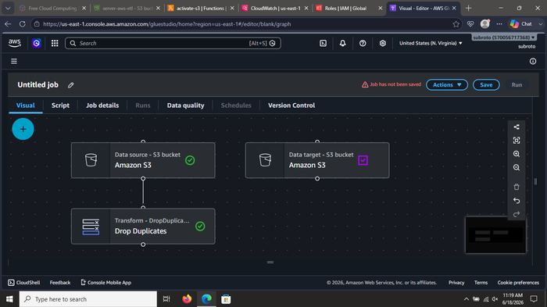
What was done: Configured the Data Source node: selected S3 bucket server-aws-etl as the input location for the ETL job.

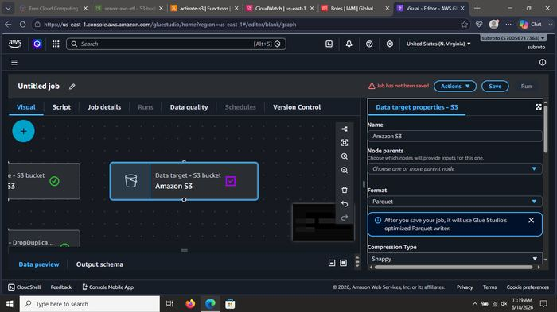
What was done: Configured the Data Source node: selected S3 bucket server-aws-etl as the input location for the ETL job.

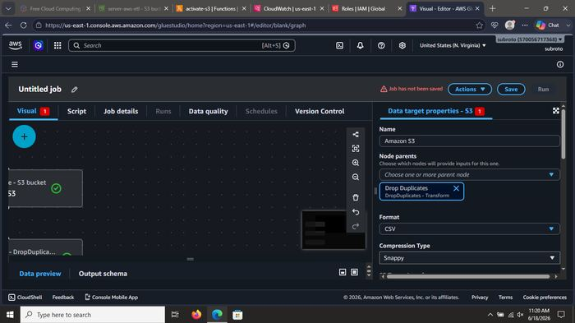
What was done: Configured the Data Source node: selected S3 bucket server-aws-etl as the input location for the ETL job.

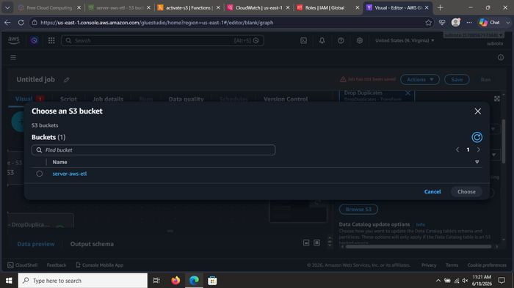
What was done: Configured the Data Source node: selected S3 bucket server-aws-etl as the input location for the ETL job.

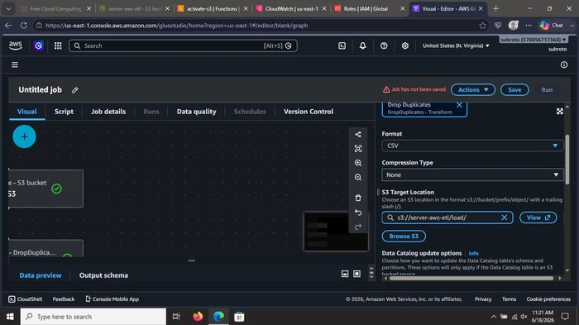
What was done: Added the Transform node Drop Duplicates to the visual job graph. This step removes duplicate rows from the incoming CSV (Titanic dataset).

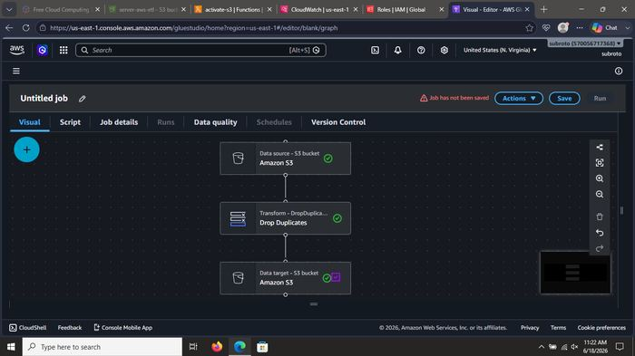
What was done: Added the Transform node Drop Duplicates to the visual job graph. This step removes duplicate rows from the incoming CSV (Titanic dataset).

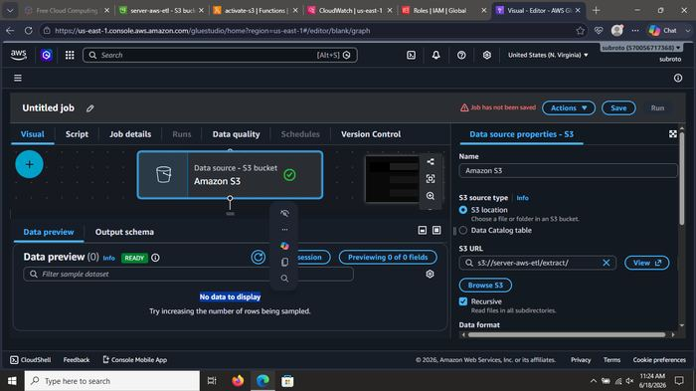
What was done: Added the Transform node Drop Duplicates to the visual job graph. This step removes duplicate rows from the incoming CSV (Titanic dataset).

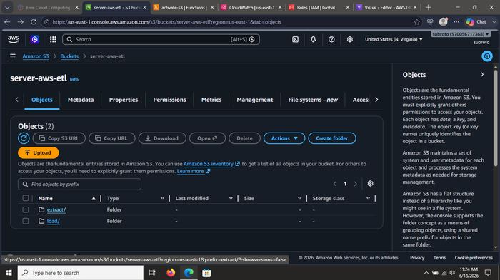
What was done: Added the Transform node Drop Duplicates to the visual job graph. This step removes duplicate rows from the incoming CSV (Titanic dataset).

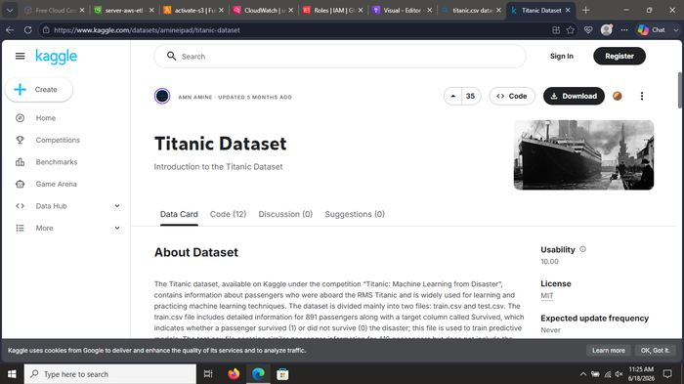
What was done: Added the Transform node Drop Duplicates to the visual job graph. This step removes duplicate rows from the incoming CSV (Titanic dataset).

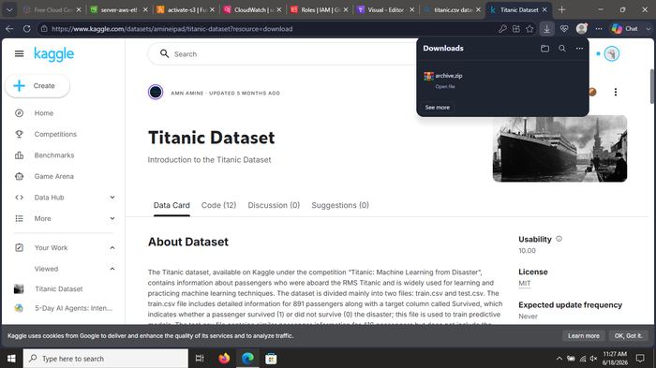
What was done: Added the Transform node Drop Duplicates to the visual job graph. This step removes duplicate rows from the incoming CSV (Titanic dataset).

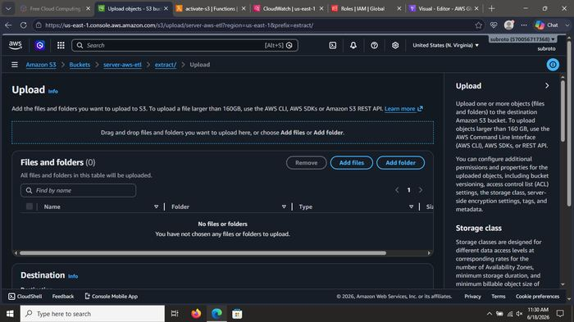
What was done: Added the Transform node Drop Duplicates to the visual job graph. This step removes duplicate rows from the incoming CSV (Titanic dataset).

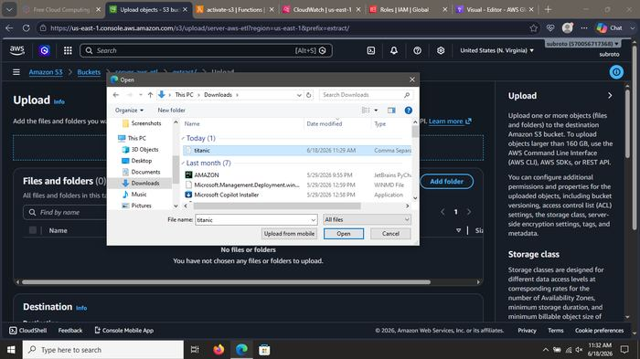
What was done: Added the Transform node Drop Duplicates to the visual job graph. This step removes duplicate rows from the incoming CSV (Titanic dataset).

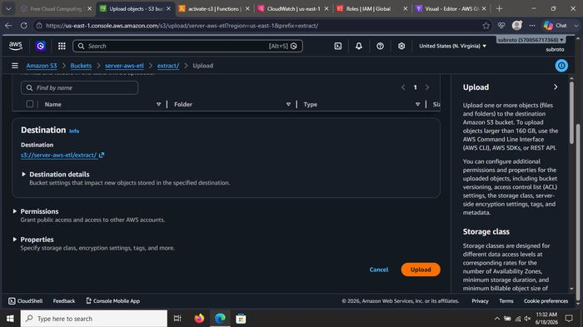
What was done: Added the Transform node Drop Duplicates to the visual job graph. This step removes duplicate rows from the incoming CSV (Titanic dataset).

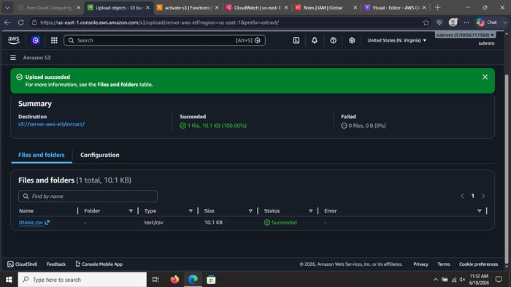
What was done: Configured the Data Target node: write the cleaned data back to S3 (processed / load prefix).

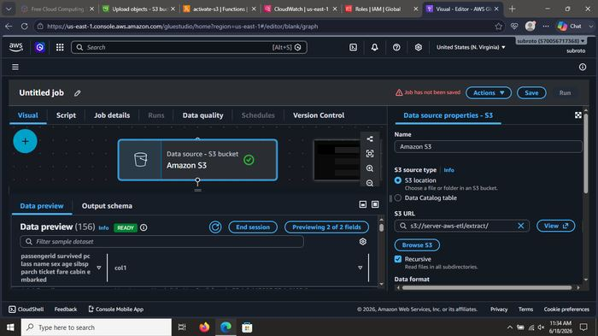
What was done: Configured the Data Target node: write the cleaned data back to S3 (processed / load prefix).

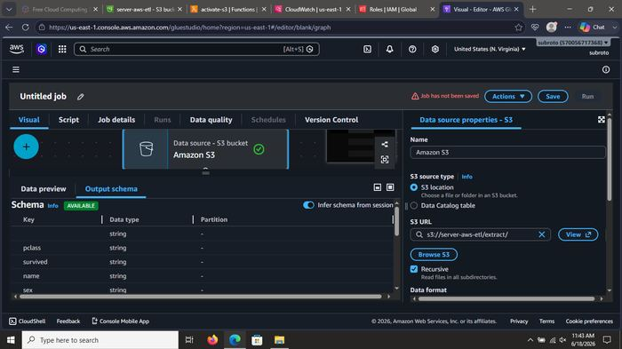
What was done: Configured the Data Target node: write the cleaned data back to S3 (processed / load prefix).

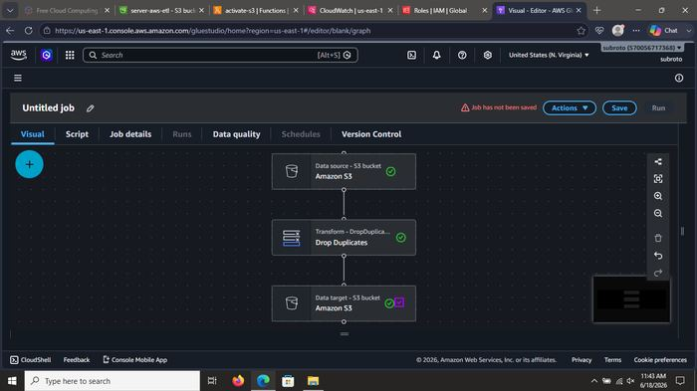
What was done: Configured the Data Target node: write the cleaned data back to S3 (processed / load prefix).

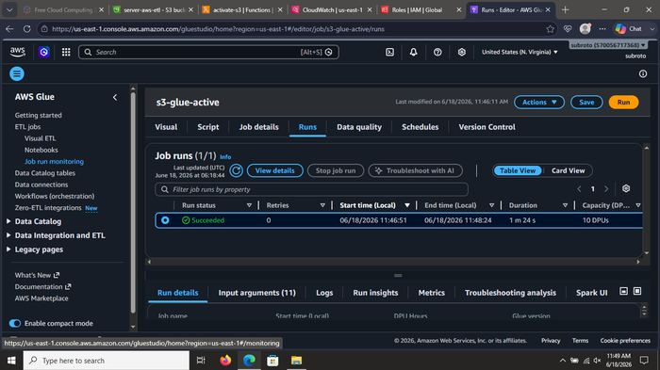
What was done: Saved the Glue job as s3-glue-active and ran it. Job completed successfully (Succeeded status, ~1–2 minutes, 10 DPUs).

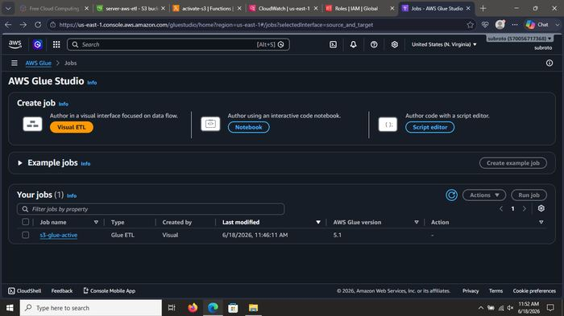
What was done: Saved the Glue job as s3-glue-active and ran it. Job completed successfully (Succeeded status, ~1–2 minutes, 10 DPUs).

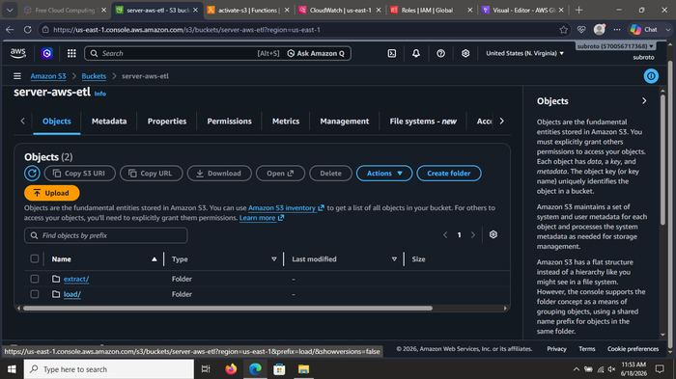
What was done: Saved the Glue job as s3-glue-active and ran it. Job completed successfully (Succeeded status, ~1–2 minutes, 10 DPUs).

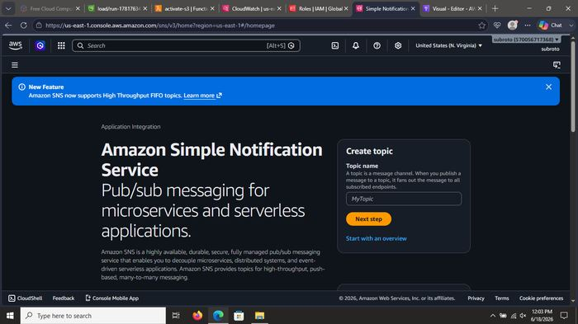
What was done: Saved the Glue job as s3-glue-active and ran it. Job completed successfully (Succeeded status, ~1–2 minutes, 10 DPUs).

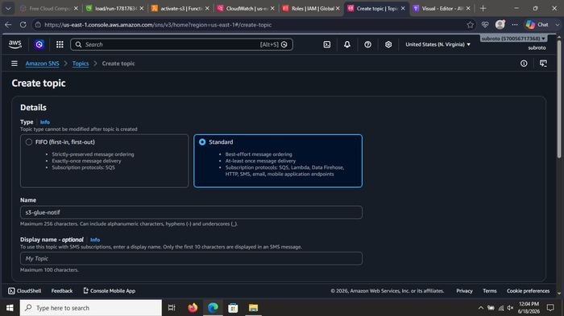
What was done: Saved the Glue job as s3-glue-active and ran it. Job completed successfully (Succeeded status, ~1–2 minutes, 10 DPUs).

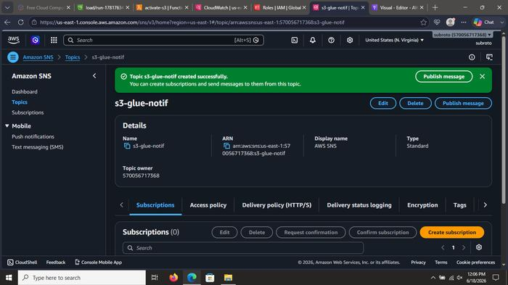
What was done: Created Amazon EventBridge rules to capture S3 Object Created events and Glue Job State Change events.

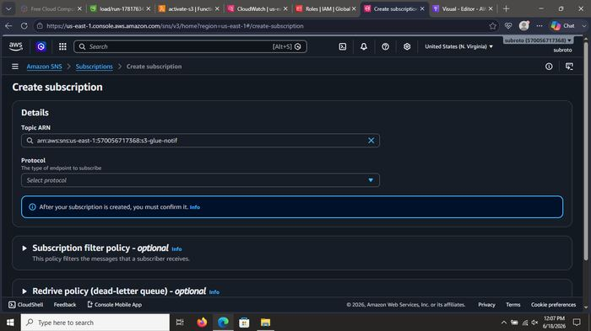
What was done: Created Amazon EventBridge rules to capture S3 Object Created events and Glue Job State Change events.

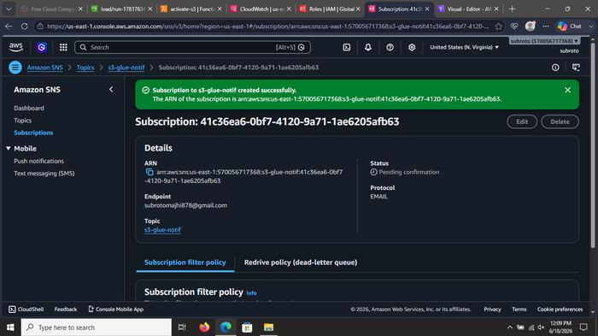
What was done: Created Amazon EventBridge rules to capture S3 Object Created events and Glue Job State Change events.

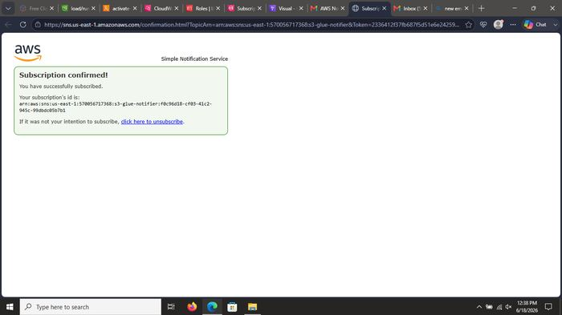
What was done: Created Amazon EventBridge rules to capture S3 Object Created events and Glue Job State Change events.

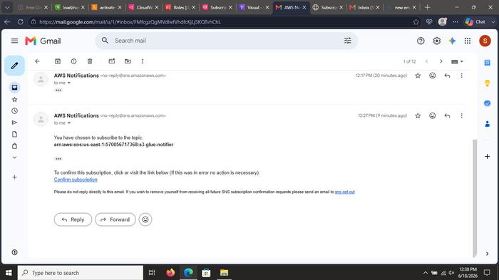
What was done: Created Amazon EventBridge rules to capture S3 Object Created events and Glue Job State Change events.

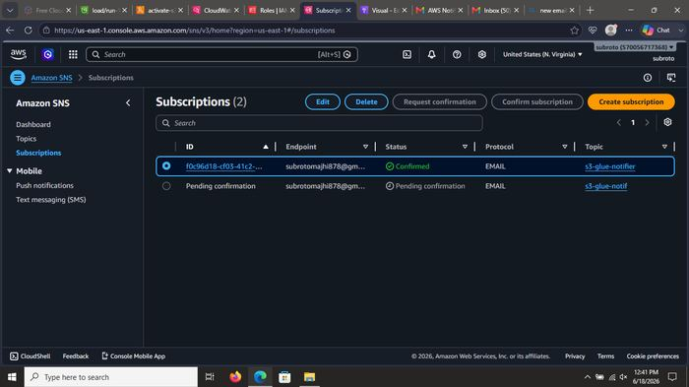
What was done: Created Amazon EventBridge rules to capture S3 Object Created events and Glue Job State Change events.

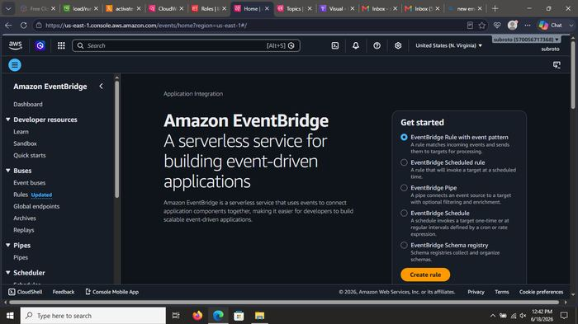
What was done: Created Amazon EventBridge rules to capture S3 Object Created events and Glue Job State Change events.

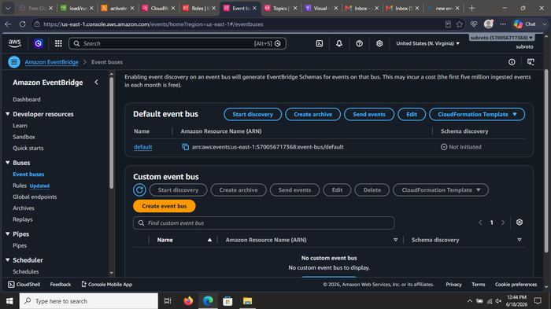
What was done: Created Amazon EventBridge rules to capture S3 Object Created events and Glue Job State Change events.

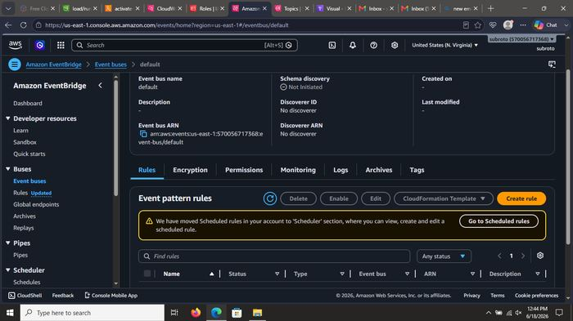
What was done: Created Amazon EventBridge rules to capture S3 Object Created events and Glue Job State Change events.

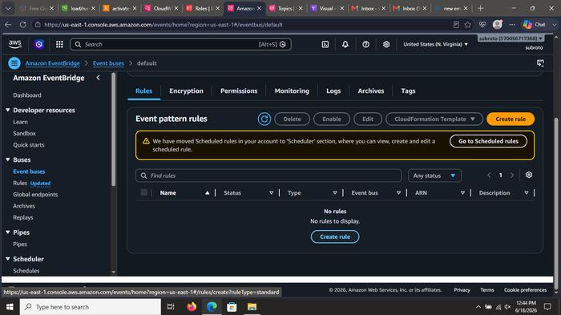
What was done: Created Amazon EventBridge rules to capture S3 Object Created events and Glue Job State Change events.

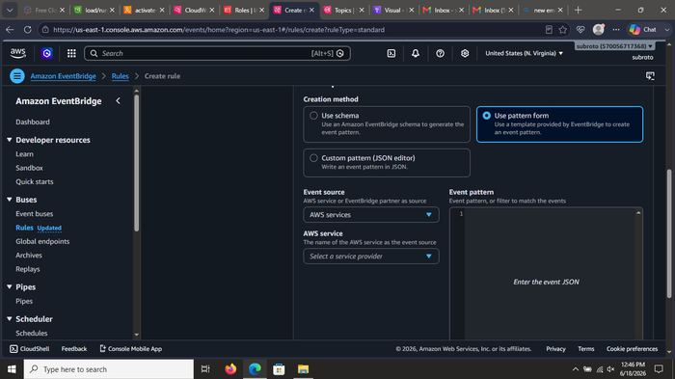
What was done: Configured EventBridge target: SNS topic s3-glue-notifier. Created the required execution role so EventBridge can publish to SNS.

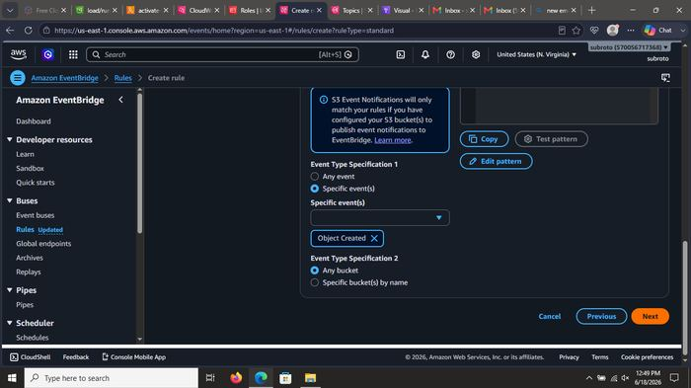
What was done: Configured EventBridge target: SNS topic s3-glue-notifier. Created the required execution role so EventBridge can publish to SNS.

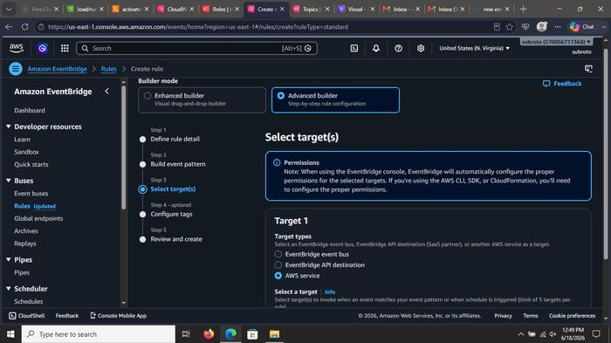
What was done: Configured EventBridge target: SNS topic s3-glue-notifier. Created the required execution role so EventBridge can publish to SNS.

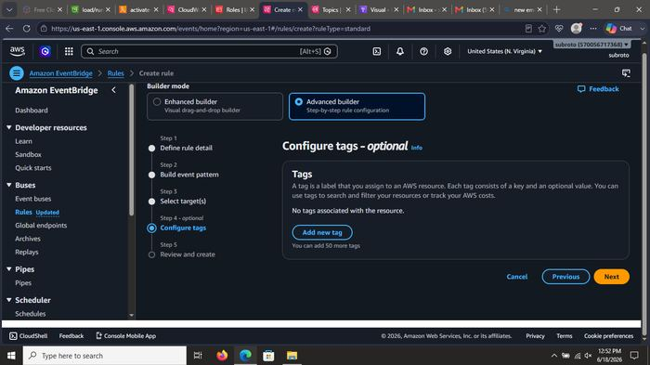
What was done: Configured EventBridge target: SNS topic s3-glue-notifier. Created the required execution role so EventBridge can publish to SNS.

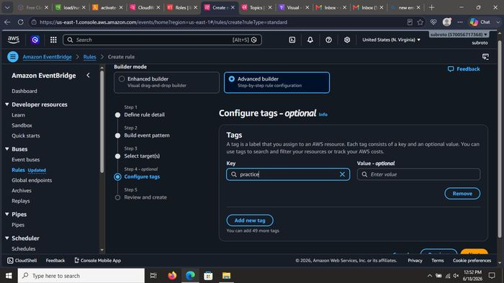
What was done: Configured EventBridge target: SNS topic s3-glue-notifier. Created the required execution role so EventBridge can publish to SNS.

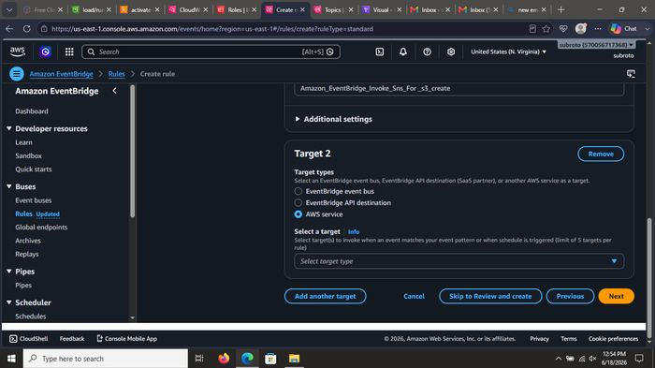
What was done: Configured EventBridge target: SNS topic s3-glue-notifier. Created the required execution role so EventBridge can publish to SNS.

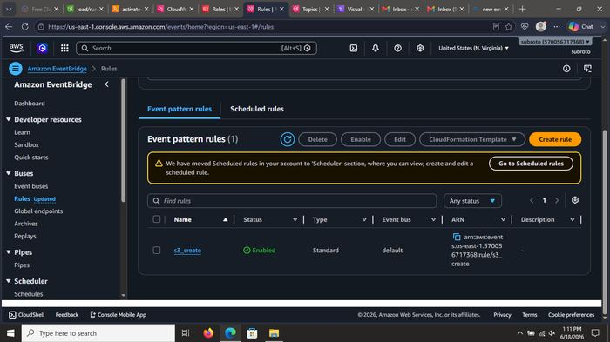
What was done: Set up the SNS topic subscription (email protocol). Confirmed the subscription so notifications are delivered to the user’s Gmail inbox.

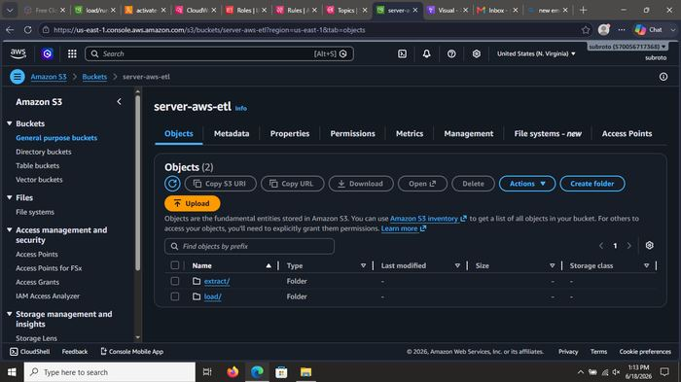
What was done: Set up the SNS topic subscription (email protocol). Confirmed the subscription so notifications are delivered to the user’s Gmail inbox.

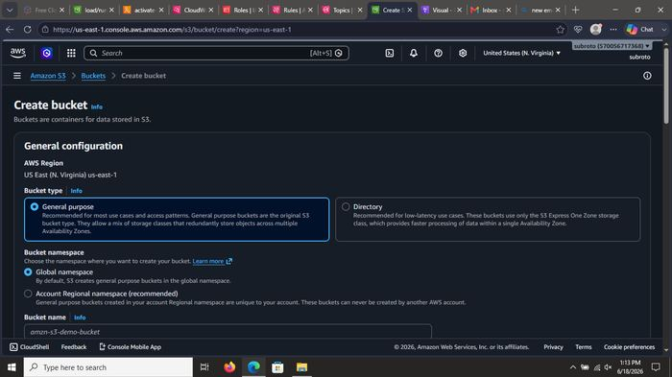
What was done: Set up the SNS topic subscription (email protocol). Confirmed the subscription so notifications are delivered to the user’s Gmail inbox.

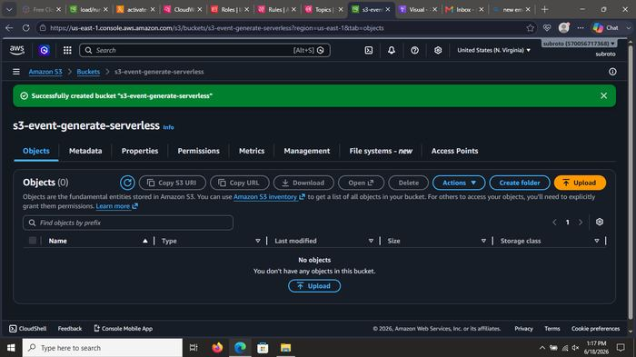
What was done: Set up the SNS topic subscription (email protocol). Confirmed the subscription so notifications are delivered to the user’s Gmail inbox.

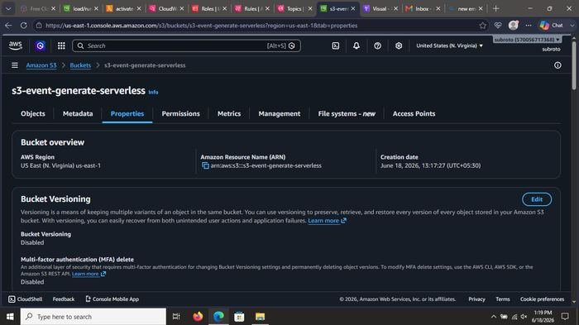
What was done: Set up the SNS topic subscription (email protocol). Confirmed the subscription so notifications are delivered to the user’s Gmail inbox.

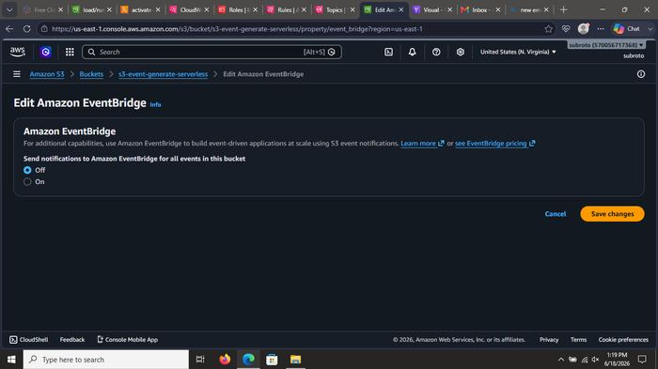
What was done: Set up the SNS topic subscription (email protocol). Confirmed the subscription so notifications are delivered to the user’s Gmail inbox.

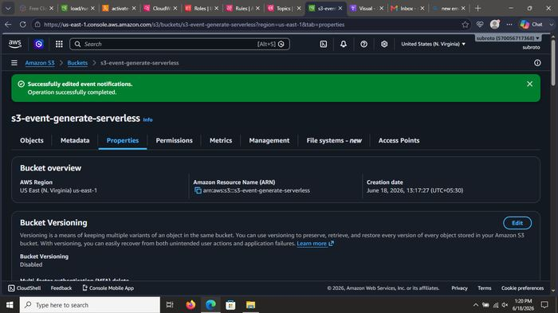
What was done: Set up the SNS topic subscription (email protocol). Confirmed the subscription so notifications are delivered to the user’s Gmail inbox.

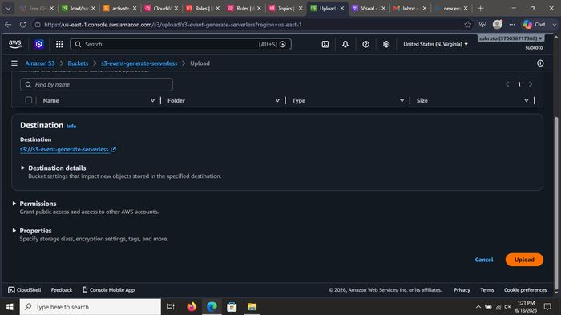
What was done: Verified CloudWatch log events showing the S3 object upload details (e.g. titanic CSV files) and the Lambda/Glue activity that followed.

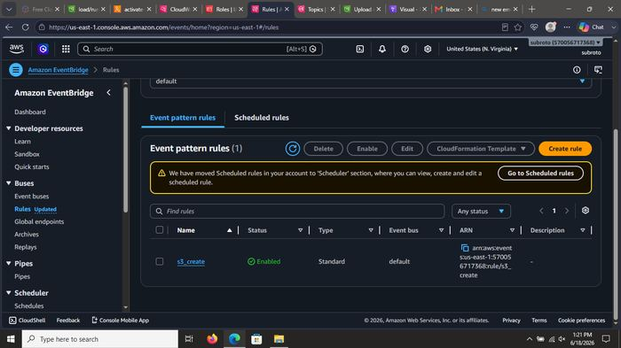
What was done: Verified CloudWatch log events showing the S3 object upload details (e.g. titanic CSV files) and the Lambda/Glue activity that followed.

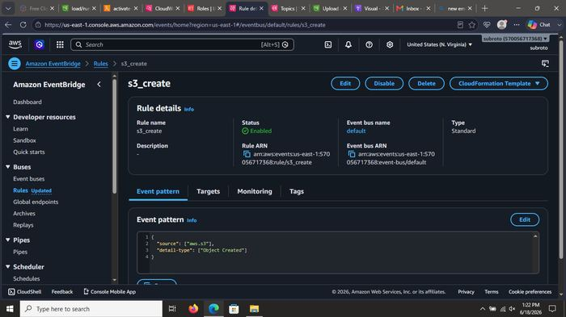
What was done: Verified CloudWatch log events showing the S3 object upload details (e.g. titanic CSV files) and the Lambda/Glue activity that followed.

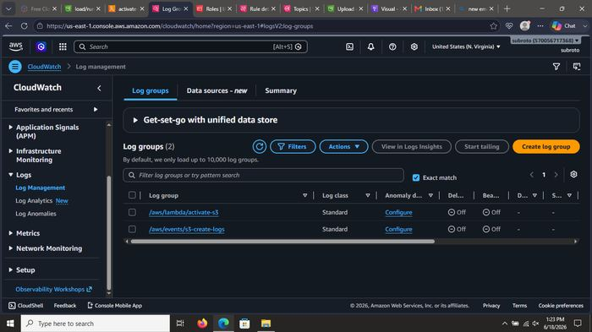
What was done: Verified CloudWatch log events showing the S3 object upload details (e.g. titanic CSV files) and the Lambda/Glue activity that followed.

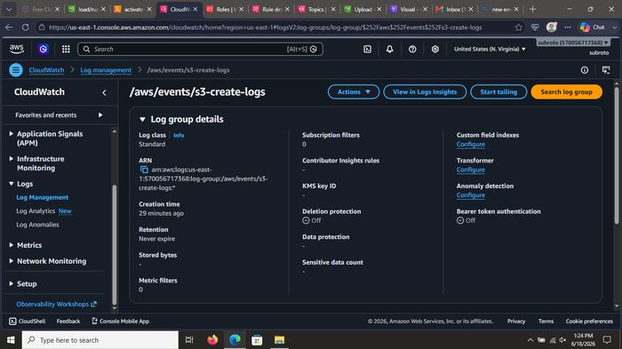
What was done: Verified CloudWatch log events showing the S3 object upload details (e.g. titanic CSV files) and the Lambda/Glue activity that followed.

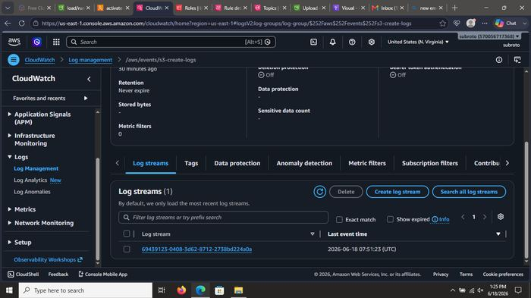
What was done: Verified CloudWatch log events showing the S3 object upload details (e.g. titanic CSV files) and the Lambda/Glue activity that followed.

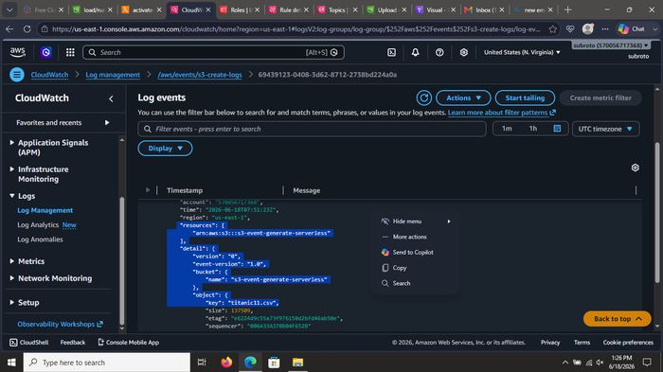
What was done: Verified CloudWatch log events showing the S3 object upload details (e.g. titanic CSV files) and the Lambda/Glue activity that followed.

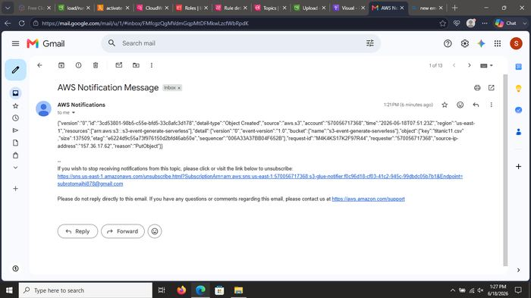
What was done: Verified CloudWatch log events showing the S3 object upload details (e.g. titanic CSV files) and the Lambda/Glue activity that followed.

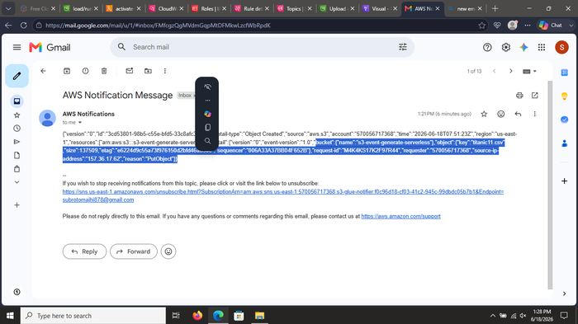
What was done: Verified CloudWatch log events showing the S3 object upload details (e.g. titanic CSV files) and the Lambda/Glue activity that followed.

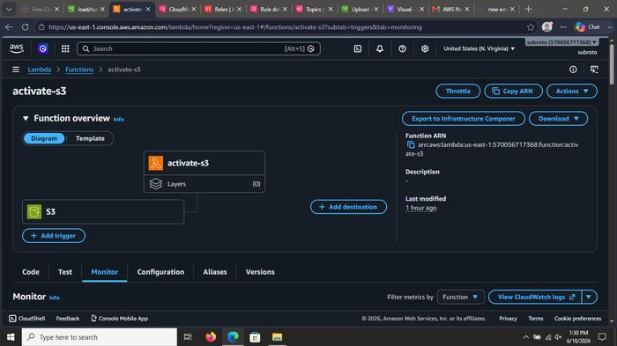
What was done: Verified CloudWatch log events showing the S3 object upload details (e.g. titanic CSV files) and the Lambda/Glue activity that followed.

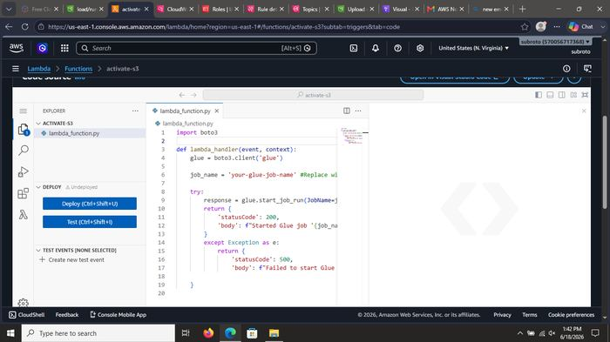
What was done: Verified CloudWatch log events showing the S3 object upload details (e.g. titanic CSV files) and the Lambda/Glue activity that followed.

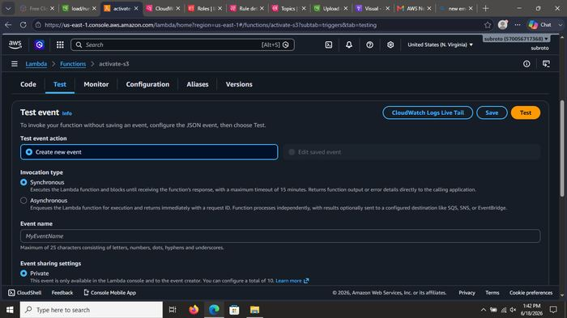
What was done: Verified CloudWatch log events showing the S3 object upload details (e.g. titanic CSV files) and the Lambda/Glue activity that followed.

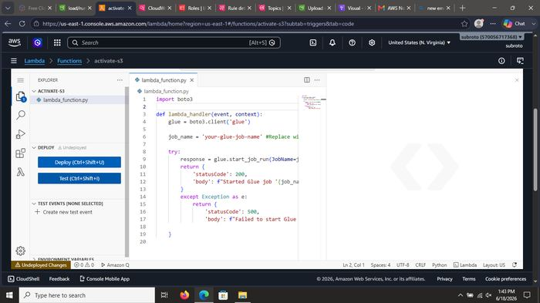
What was done: Verified CloudWatch log events showing the S3 object upload details (e.g. titanic CSV files) and the Lambda/Glue activity that followed.

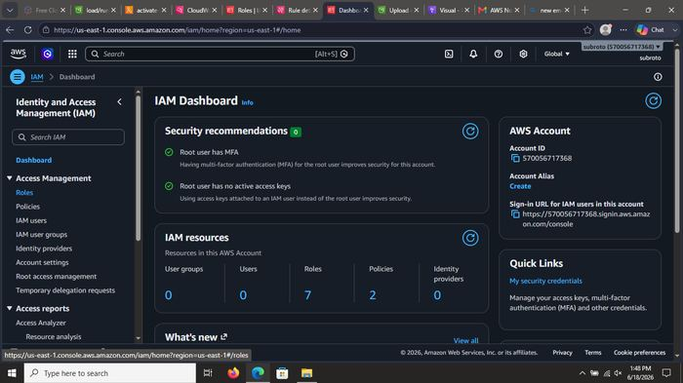
What was done: Checked the Glue job Runs tab. Confirmed multiple successful runs of s3-glue-active (status Succeeded).

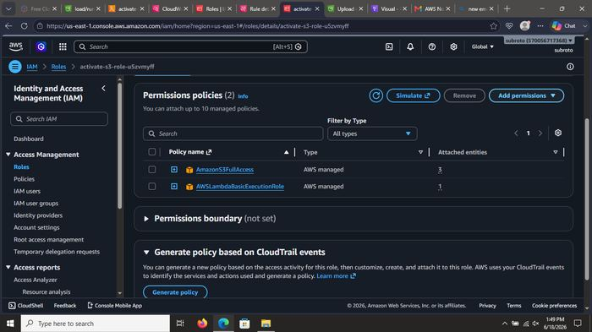
What was done: Checked the Glue job Runs tab. Confirmed multiple successful runs of s3-glue-active (status Succeeded).

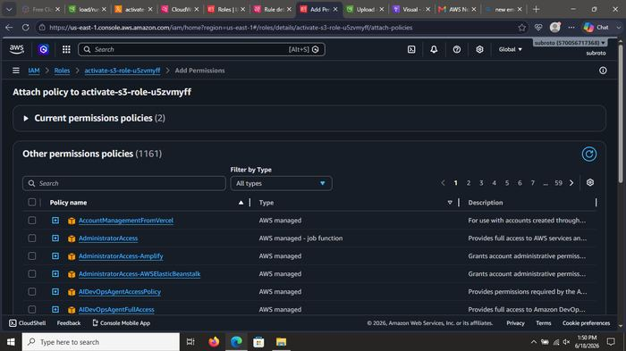
What was done: Checked the Glue job Runs tab. Confirmed multiple successful runs of s3-glue-active (status Succeeded).

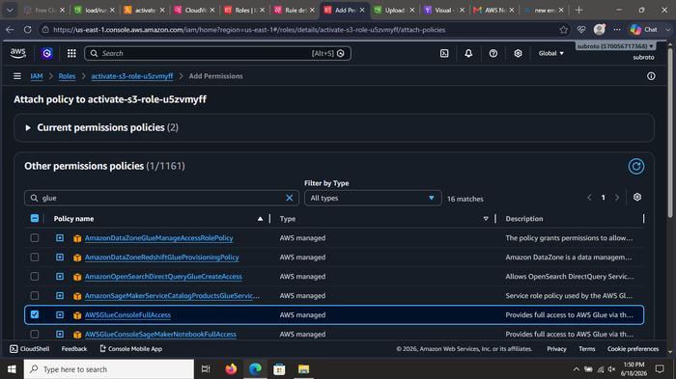
What was done: Checked the Glue job Runs tab. Confirmed multiple successful runs of s3-glue-active (status Succeeded).

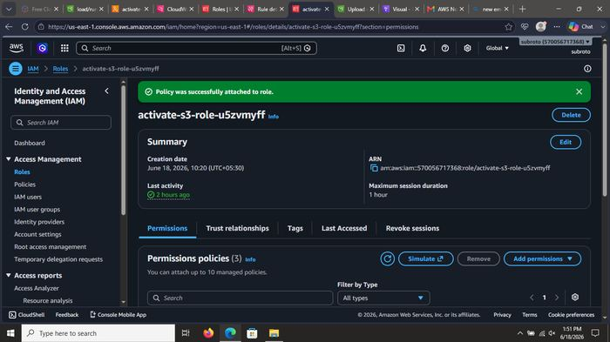
What was done: Checked the Glue job Runs tab. Confirmed multiple successful runs of s3-glue-active (status Succeeded).

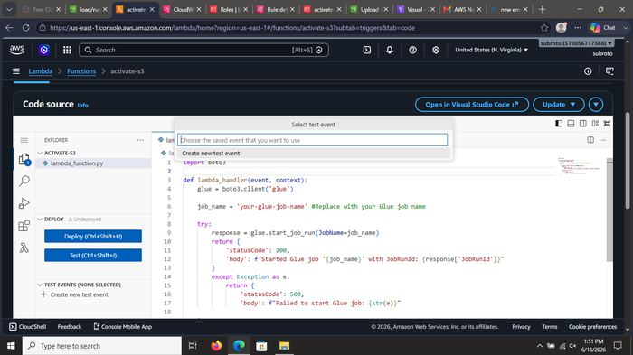
What was done: Checked the Glue job Runs tab. Confirmed multiple successful runs of s3-glue-active (status Succeeded).

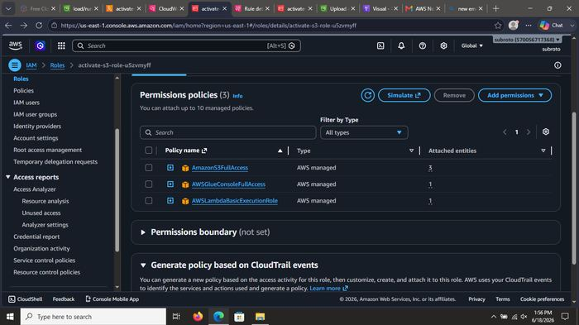
What was done: Checked the Glue job Runs tab. Confirmed multiple successful runs of s3-glue-active (status Succeeded).

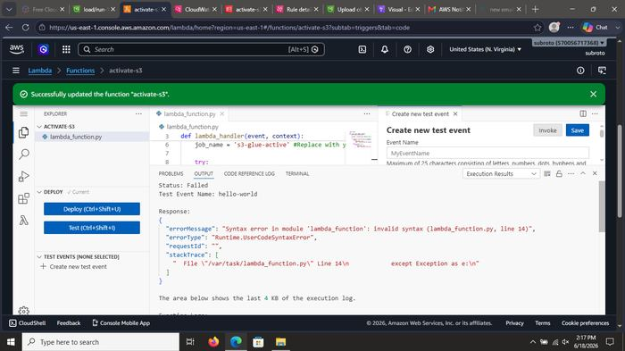
What was done: Checked the Glue job Runs tab. Confirmed multiple successful runs of s3-glue-active (status Succeeded).

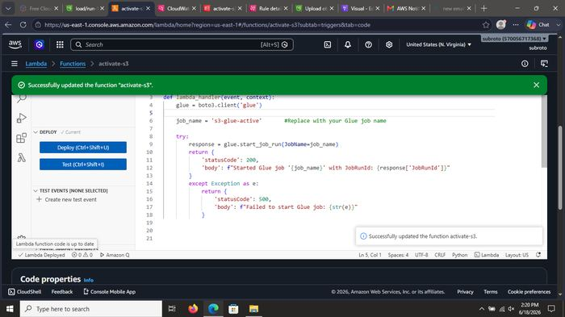
What was done: Checked the Glue job Runs tab. Confirmed multiple successful runs of s3-glue-active (status Succeeded).

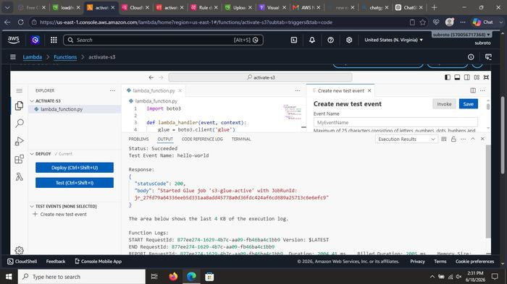
What was done: Checked the Glue job Runs tab. Confirmed multiple successful runs of s3-glue-active (status Succeeded).

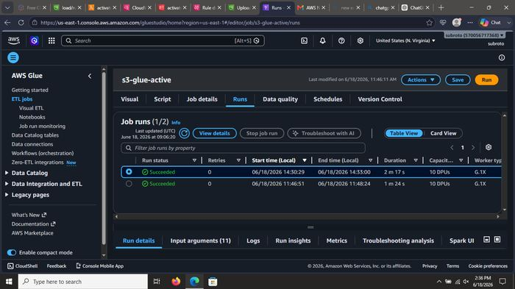
What was done: Checked the Glue job Runs tab. Confirmed multiple successful runs of s3-glue-active (status Succeeded).

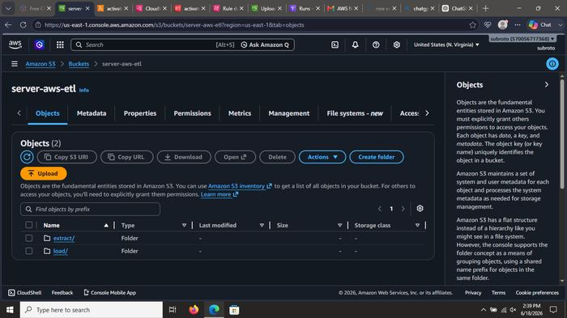
What was done: Uploaded the final test file (titanic.csv) into the extract/ prefix of the S3 bucket. Upload completed successfully.

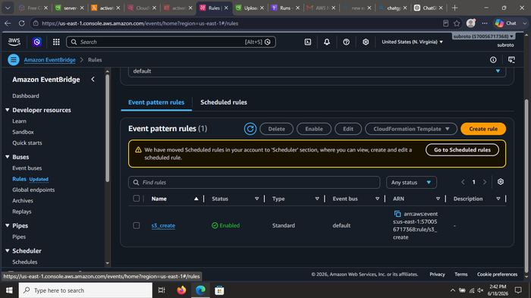
What was done: Uploaded the final test file (titanic.csv) into the extract/ prefix of the S3 bucket. Upload completed successfully.

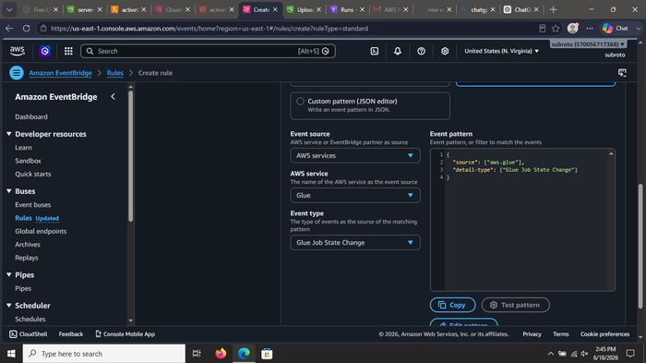
What was done: Uploaded the final test file (titanic.csv) into the extract/ prefix of the S3 bucket. Upload completed successfully.

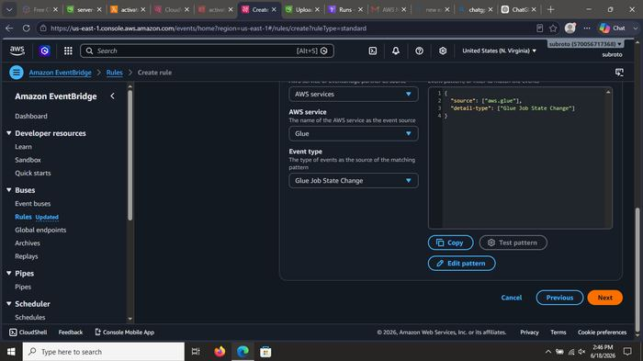
What was done: Uploaded the final test file (titanic.csv) into the extract/ prefix of the S3 bucket. Upload completed successfully.

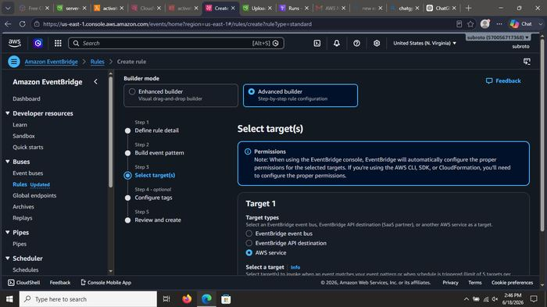
What was done: Uploaded the final test file (titanic.csv) into the extract/ prefix of the S3 bucket. Upload completed successfully.

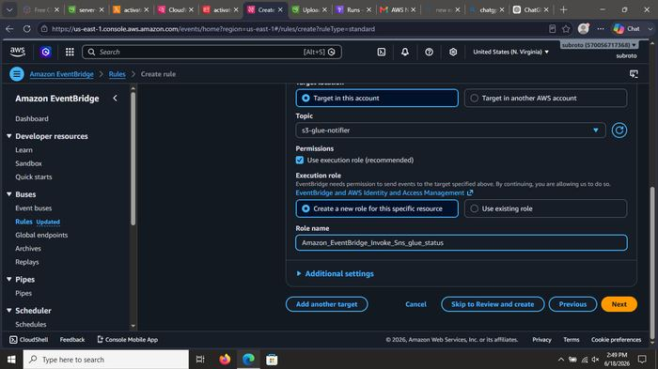
What was done: Uploaded the final test file (titanic.csv) into the extract/ prefix of the S3 bucket. Upload completed successfully.

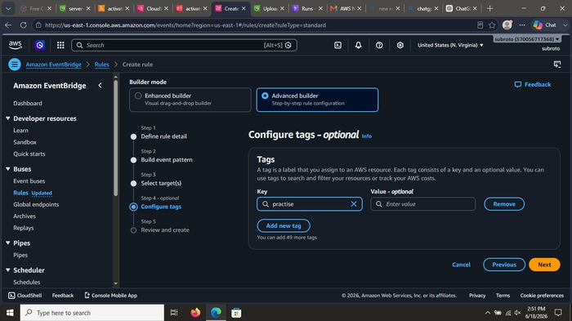
What was done: Uploaded the final test file (titanic.csv) into the extract/ prefix of the S3 bucket. Upload completed successfully.

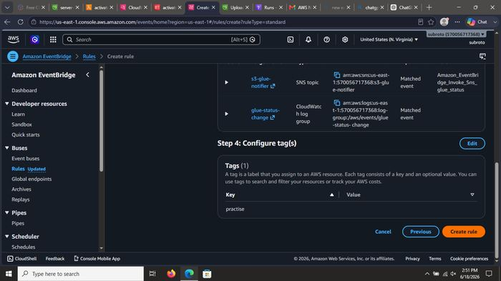
What was done: Uploaded the final test file (titanic.csv) into the extract/ prefix of the S3 bucket. Upload completed successfully.

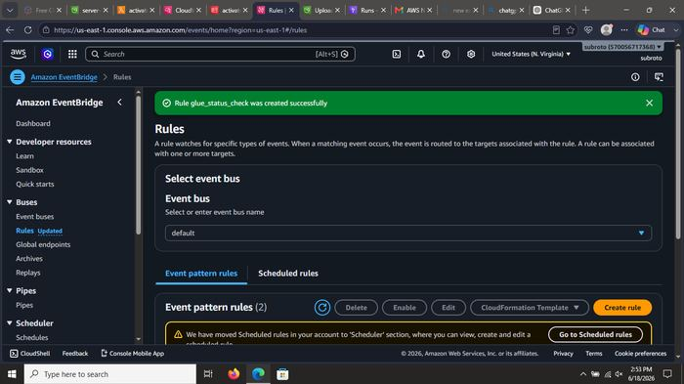
What was done: Uploaded the final test file (titanic.csv) into the extract/ prefix of the S3 bucket. Upload completed successfully.

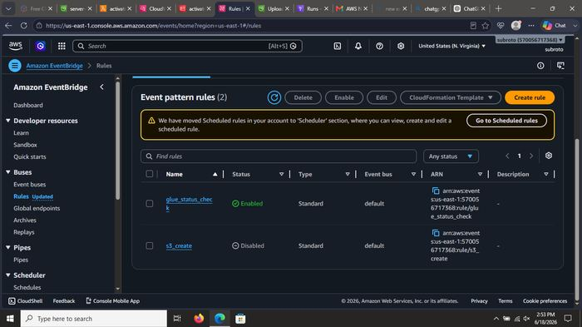
What was done: Uploaded the final test file (titanic.csv) into the extract/ prefix of the S3 bucket. Upload completed successfully.

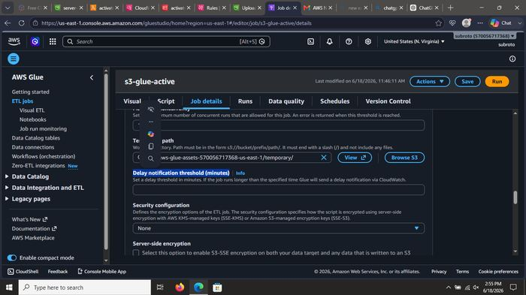
What was done: Monitored EventBridge and SNS delivery status to ensure events were correctly routed to the notification topic.

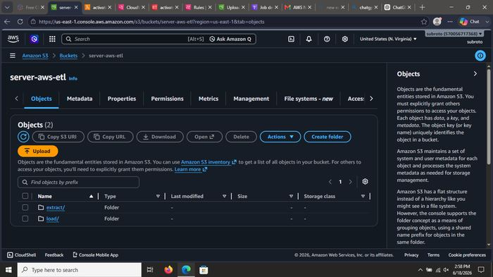
What was done: Monitored EventBridge and SNS delivery status to ensure events were correctly routed to the notification topic.

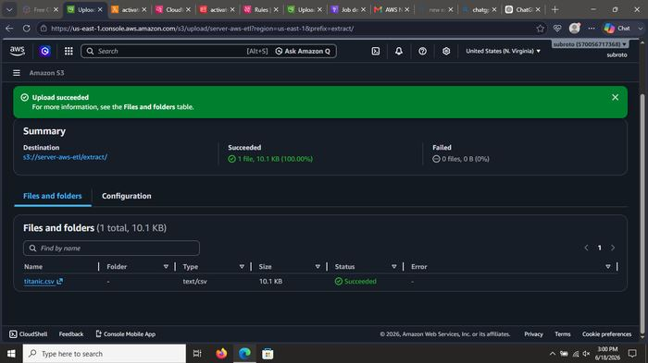
What was done: Monitored EventBridge and SNS delivery status to ensure events were correctly routed to the notification topic.

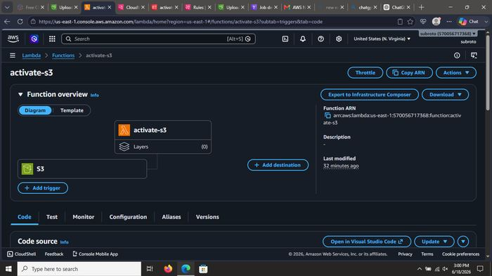
What was done: Monitored EventBridge and SNS delivery status to ensure events were correctly routed to the notification topic.

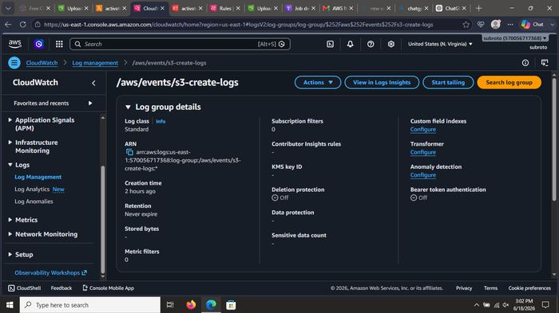
What was done: Monitored EventBridge and SNS delivery status to ensure events were correctly routed to the notification topic.

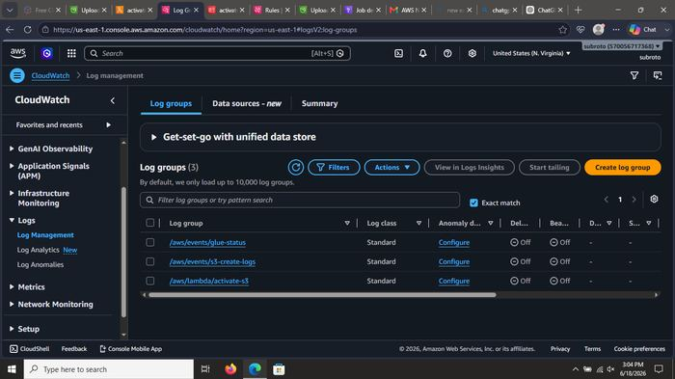
What was done: Monitored EventBridge and SNS delivery status to ensure events were correctly routed to the notification topic.

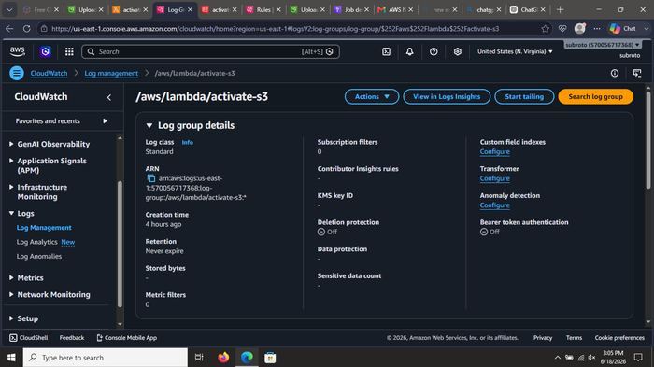
What was done: Monitored EventBridge and SNS delivery status to ensure events were correctly routed to the notification topic.

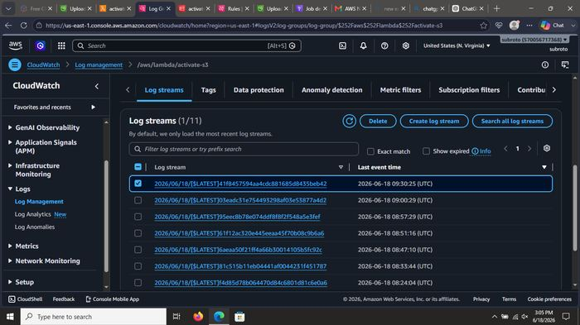
What was done: Monitored EventBridge and SNS delivery status to ensure events were correctly routed to the notification topic.

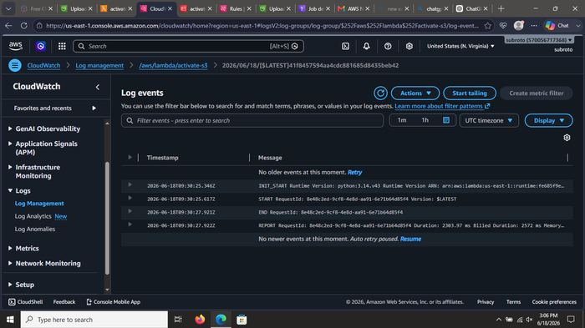
What was done: Monitored EventBridge and SNS delivery status to ensure events were correctly routed to the notification topic.

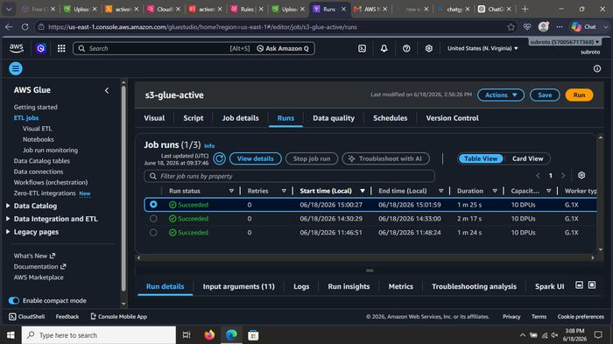
What was done: Monitored EventBridge and SNS delivery status to ensure events were correctly routed to the notification topic.

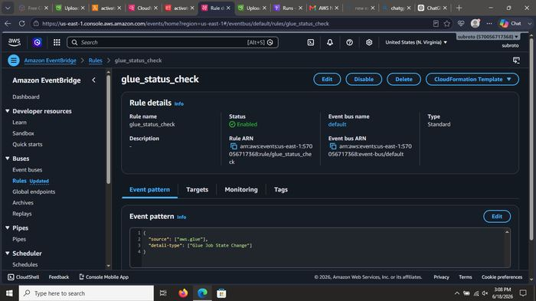
What was done: Opened Gmail inbox and verified receipt of AWS Notification Messages: Object Created event and Glue Job State Change (SUCCEEDED).

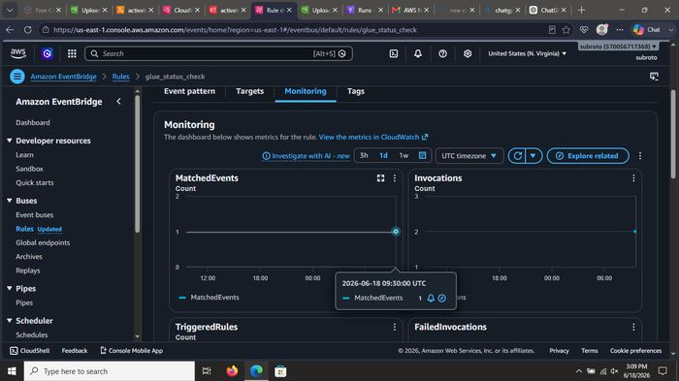
What was done: Opened Gmail inbox and verified receipt of AWS Notification Messages: Object Created event and Glue Job State Change (SUCCEEDED).

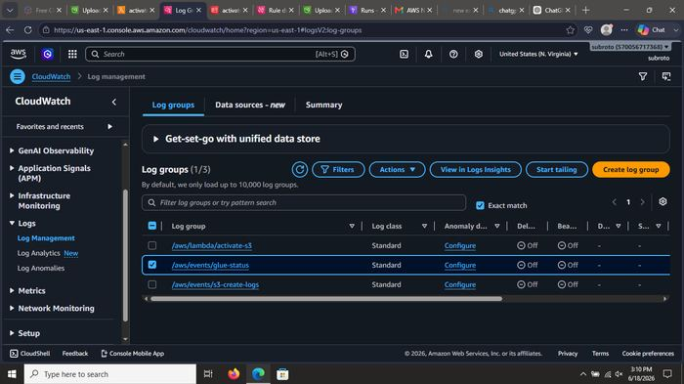
What was done: Opened Gmail inbox and verified receipt of AWS Notification Messages: Object Created event and Glue Job State Change (SUCCEEDED).

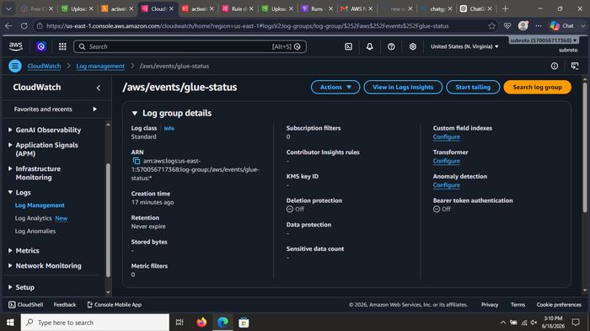
What was done: Opened Gmail inbox and verified receipt of AWS Notification Messages: Object Created event and Glue Job State Change (SUCCEEDED).

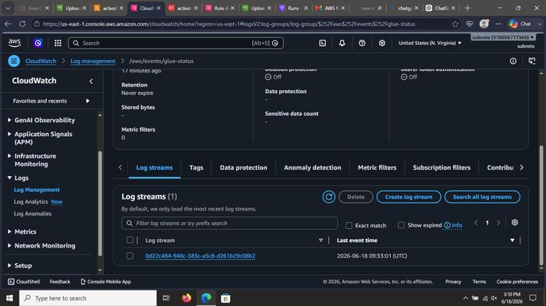
What was done: Opened Gmail inbox and verified receipt of AWS Notification Messages: Object Created event and Glue Job State Change (SUCCEEDED).

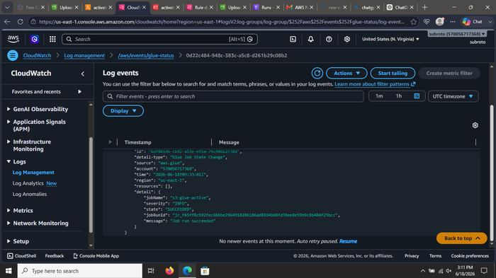
What was done: Opened Gmail inbox and verified receipt of AWS Notification Messages: Object Created event and Glue Job State Change (SUCCEEDED).

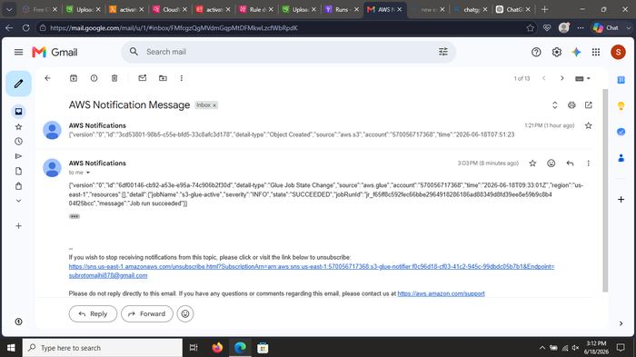
What was done: Opened Gmail inbox and verified receipt of AWS Notification Messages: Object Created event and Glue Job State Change (SUCCEEDED).

Summary – What This Project Demonstrates
- Serverless architecture: no servers to manage (S3, Lambda, Glue, EventBridge, SNS).
- Event-driven design: S3 object upload automatically triggers the pipeline.
- Visual ETL with AWS Glue Studio – Drop Duplicates transform applied to Titanic CSV data.
- Real-time notifications via SNS email when objects are created or Glue jobs succeed.
- Full observability through CloudWatch Logs.
- IAM least-privilege roles for security.

